A PROJECT REPORT ON

COMMODITY INTELLIGENCE SYSTEM

Submitted to JNT university for the partial fulfillment of the
Requirement for the

Award of Degree for

MCA

Done by

Mr. /Miss. XXXXXX

Rao and Naidu Engg College

Ongole

CERTIFICATE

This is to certify that Mr. XXXX, bearing Roll No. XXXXXXXXXXX have developed Software project titled XXXXXXXX for Sagitta Software Technologies as a partial Fulfillment for the award of the Degree of XXXXXXX.

HEAD OF DEPARTMENT PRINCIPAL
Rao and Naidu Engg College
Computer Sciences

EXTERNAL

ACKNOWLEDGMENT

My express thanks and gratitude and thanks to Almighty God, my parents and other family members and friends without whose support, I could not have made this project successful.

I wish to place on my record my deep sense of gratitude to my project guide, Mr. P.Sriram, Sun Informatics, Hyderabad for his constant motivation and valuable help through the project work. Express my gratitude to Mr. Siva Rao, Director of Sun Informatics for his valuable suggestions and advices through out the course I am very much thankful to our Head Of The Department Mr. I also extend my thanks to other Faculties for their Cooperation during my Course.

Finally I would like to thank my friends for their cooperation to complete this project.

Finally I would like to thank my friends for their cooperation to complete this project.

PREFACE

In an era where having a website of your own is a matter of prestige for some and necessity for others. Management of these websites is still an area which is ignored or done in traditional manner. In a changing world no corporate company or any website owner would like to host a static content over their site. We in a system called ‘Commodity Intelligence System’ provide a structural mechanism of building the content for your site. It also provides us a testing area where the created content is being hosted.
The structural mechanism provides in this system requires personal with specialization in different areas. The entire content is grilled through various phases before being made available for the website. The content being created or hosted can be placed into different categories available with the system. The crucial content can even be placed in a protected zone which can be accessed by only the registered users.
This application provides most of the features required to manage the projects developed in a software development firm.
This volume presents the manner in which the software was developed and how the various problems are tackled at the different levels to convince the user.
We hope that this package would prove to be an excellent environment for simpler for end user.

Enter Your Name

CONTENTS

- INTRODUCTION
  - INTRODUCTION TO CIS
  - PURPOSE OF THE PROJECT
  - PROBLEM IN EXISTING SYSTEM
  - SOLUTION OF THESE PROBLEMS
  - SCOPE OF THE PROJECT

- PROJECT ANALYSIS
  - STUDY OF THE SYSTEM
  - HARDWARE & SOFTWARE SPECIFICATIONS
  - INPUT & OUTPUT
  - PROCESS MODELS USED WITH JUSTIFICATION

- SELECTED SOFTWARE

- SOFTWARE REQUIRMENT SPECIFICATION
- FUNCTIONAL REQUIREMENTS
- PERFORMANCE REQUIREMENTS

- PROJECT DESIGN
- DATA DICTIONARY
- E-R DIAGRAM
- DATA FLOW DIAGRAMS

- OUTPUT SCREENS

7) PROJECT TESTING
  - COMPILING TEST
  - EXECUTION TEST
  - OUTPUT TEST

- FUTURE IMPROVEMENT

9) CONCLUSION

10) BIBLOGRAPHY

INTRODUCITON

SUNINFORMATICS
8-3-214/7/1, Plot No: 127, Gajalakshmi Estates, 3rd Floor, S.R.Nagar,
Hyderabad-38, Phone no: 91-40-64517776,www.Suninformatic.com, E-mail:info@suninformatic.com

Sun Informatics Executive Summary

Sun Informatics is a Hyderabad based IT and Management consulting firm that offers a broad portfolio of technology and manpower staffing solutions. Sun Informatics is differentiated by its tradition of unsurpassed technology expertise; its strong track record of delivery; and its experienced, enthusiastic people. Sun Informatics leadership in client and employee satisfaction has been recognized nationwide today.

ERP

An ERP solution aims to provide single software which will integrate all the divisions in your organization planning, manufacturing, sales, marketing, finance, HR and yet fulfill each division’s information and planning needs. ERP streamlines processes within your organization and helps you meet business needs more efficiently and quickly.

Clients

Sun Informatics works with clients ranging from small, start-up organizations to large, well-established corporations. The company’s client base represents a wide variety of industries, including agriculture, Engineering Industries, banking / finance, Telecommunications, healthcare, manufacturing, and of course IT.

Client Services :

Sun Informatics is a leading provider of full-service staffing solutions for a broad range of companies throughout the Hyderabad and nationally. Our recruiters can assist you with your specific staffing needs in all key-staffing areas:
Direct Placement: Our research capabilities, industry expertise, extensive network of contacts and determination allows us to find the top performers that best fit your particular requirements.

Interim Staffing: We recruit highly qualified interim professionals for companies seeking an alternative to regular staffing as a strategy for growth.

Right-Fit Services: Our staffing solutions deliver the right talent to you with right-fit innovative services that include compatibility assessment, private videoconferencing, outplacement and relocation assistance.

We are committed to providing our clients with unsurpassed levels of quality and service. We have already accomplished this goal for numerous clients. It's a mission we're ready to fulfill for you.

How We Do It : As part of the Sun Informatics network, Sun Informatics Nationwide commands state-of-the-art tools that help you make the right decision about your company's most important asset—your people.

Search and Selection Process: Ask about our proven comprehensive strategy for securing the best talent.

Confidentiality: Protect your company's confidentiality with our confidential search services.

Compatibility Assessment: Avoid costly hiring mistakes with expert recruiters through Sun Informatics, our reliable compatibility assessment tool.

International Staffing: Leverage our global network to meet your international recruiting needs.

Project Outsourcing: Let us create a nationwide project team for your large staffing assignments.

Videoconferencing: Conduct long-distance face-to-face interviews with Videoconferencing by Sun Informatics.

Relocation Services: Reduce impediments associated with relocating candidates with Sun Informatics innovative relocation services that include cost-of-living analysis, moving and travel assistance.

How To Engage Us : Our flexible engagement options include retained search, priority search and contingency search. Contact us to learn more and to determine which option is right for your recruiting needs.

QUALITY : We have made Quality a way of life at Sun Informatics, the core of the work we do, and the way we do it. This involves re-use of best and smart practices, consistent improvement and improvisation of our methodologies and processes, which inculcate a sense of doing things, right-the first time and every time.
By adopting new standards and a relentless pursuit of continuous improvement in our quality management systems and processes, we continue to ensure commitment to customer satisfaction.

ABSTRACT

Title of the Project: Commodity Intelligence System

Description:
Commodity Intelligence System is a Portal providing as complete solution for the commodity class which envisage a very user friendly platform for all classes which are based on commodity transactions by providing a service for every one interested in picking up commodity prices and also for pursuing the trading on-line. It is a unique concept of networking all major national trading centers and market yards across the country providing regularly updated online information about commodity prices at any particular point of time along with all structured reports vis.. trends and projections daily, weekly, monthly, yearly which are the ready for all classes requiring information on commodities
The main purpose of CIS is essentially to collect the latest fluctuating prices of commodities available and required in the market at a particular given point of time and at particular specified market locations. So that the producer, trader, consumers can get best deal out of their all commodity deals and derive reasonable profit in all levels.

Existing System:
This project provides online Commodity prices. Presently prices are not available online.
Project Goal And Objective :

- Is to achieve stability of price, supply and demand of commodity for all related activities.

- Assist planning proper production, based on accurate Supply and Demand.

- To provide accurate, timely prices and availability (Supply and Demand) of commodities to wide spectrum of society spanning farmers, businessmen, traders and consumers on-line.

- To enact as an excellent end to end business solution for all classes based on commodity trade providing an avenues to explore more business opportunities by navigating through more and more prospective range of buyers and sellers thus having a most competitive edge over all business practices and evoking more profits and reducing all unnecessary overheads.

- Complete Information Technology backbone for entire commodity market sector both essential & non-essential businessmen, producers and traders, consumers based on proven emerging technology.

Proposed System:

In this age of Globalization information is power and the whole world is running for a platform where one can meet the customer mind share and here is a platform that can outpour all needs for what so ever on Commodities. Good business is still sealed with a handshake especially on the Internet, with CIS which is pioneered virtual market place, which can make your business a real business where in one, can proudly say that the agri-world is at their tips and the pricing now rests in their hands.
Commodity Intelligence System (CIS) is a unique concept of networking all the major National Trading Centers / Marketing Yards in India and important state Trading Centers / Market Yards across the length and breadth of the country.

Scope:

The scope of work would include:

To cover the state of Andhra Pradesh out of 32 states and union territories.

MODULES OF THE APPLICATION
Groups of Functionality:

There are 3 Groups of Functionality to be made available from the CIS

The 3 Groups of Functionality are:
- MASTER
- TRANSACTION
- REPORTS

Masters :
The information specified in the Master is regarded static, in the sense that it is “Permanent” or non-changing or stable. The updates are infrequent and may be regarded as permanently stored in the Database. The Master Group has functionality to View / Change.
The master pages will have access to administrator only.
- Location
- Commodity
- Market
- Markets at Locations
- Commodity at Markets
- UOM

The information in Master may be changed only through the specified GUI.

Transaction:
Transactions deal with dynamic or transient data.
Transactions do not affect the MASTER Data.
The TRANSACTION Group of functionality is as follows:
- Commodity Prices (updating)
- Info-Supplier Registration -- Associated with every Market are sets of info-suppliers who collect Commodity Information for the markets and feed it to CIS via the Internet periodically (every one hour or at the closing time of the market for the day). An info-supplier is associated with a market (or several markets). An info-supplier is registered on a per-market.
- Customer Registration --- A customer is defined as one who is interested in receiving CIS Commodity Information and has registered for it with the CIS. A customer registers thru internet / website with the CIS.
- So, a Customer can be registered to Query for specified CIS Information REPORTS to be got from CIS.
- Search

Reports:
This group of functionality causes queries to be invoked on the CIS Database in order to generate various Reports about CIS Commodity Data.

They are:

Examples of Reports:

- Current Price (all markets)
- Daily Prices
- Low/High Prices
- Weekly Prices (on a daily basis)
- Monthly Prices (on a weekly basis)
- Quarterly Prices (on a monthly basis)
- Annual Prices (on a quarterly basis)

Software Requirements:

- WINDOWS XP
- Visual Studio .Net 2005 Enterprise Edition
- Internet Information Server 5.0
- Visual Studio .Net Framework (Minimal for Deployment)
- Sql Server 2005
- Internet Explorer
Hardware Requirements:

- Pentium IV 500MHZ or above
- 512MB RAM
- 20MB Free Hard disk space
- Color Monitor

INTRODUCTION

- PURPOSE OF THE PROJECT

In this age of Globalization information is power and the whole world is running for a platform where one can meet the customer mind share and here is a platform that can outpour all needs for what so ever on Commodities. Good business is still sealed with a handshake especially on the Internet, with CIS which is pioneered virtual market place, which can make your business a real business where in one, can proudly say that the agri-world is at their tips and the pricing now rests in their hands.
Commodity Intelligence System (CIS) is a unique concept of networking all the major National Trading Centers / Marketing Yards in India and important state Trading Centers / Market Yards across the length and breadth of the country.

- PROBLEMS IN THE EXISTING SYSTEM

An extensive study of existing system was carried out. There is an existing system available in branch. The system is run manually by database. It is difficult to run efficiently by man power, and difficult to respond every user within short period. Thus we came to know the essential need to make it web application.

- Proposed System:
The Commodity Intelligence System makes finding information about any commodity price any where online quick and easier.

SCOPE OF THE PROJECT

The scope of work would include:

To cover the state of Andhra Pradesh out of 32 states and union territories.

PROJECT ANALYSIS

- STUDY OF THE SYSTEM

The complete system can be divided into five halves on basis of access levels.
    - Account Management
    - Utilities
    - Authoring
    - Editing
    - Approving
    - Deployment

Administrator:

An administrator has all the privileges that of the guest as well as the normal registered user. Along with these common features an administrator has the administrator related features such as creating new users and granting roles to those newly created users. The roles granted by the administrator cannot be changes by the user. An administrator can create new user as a guest or as an user or an administrator. The access levels are as per the grants done by the administrator.

An administrator can also be part of a team and could lead a project team this is possible only if administrator when building a team includes himself in the team section. If included as a manager he is not a part of the team but supervisor of the team.

The register option on the homepage of the application is provided only to register a new user as a guest.

ACCESS CONTROL FOR DATA WHICH REQUIRE USER AUTHENTICATION

The following commands specify access control identifiers and they are typically used to authorize and authenticate the user (command codes are shown in parentheses)

USER NAME (USER)
- The user identification is that which is required by the server for access to its file system. This command will normally be the first command transmitted by the user after the control connections are made (some servers may require this).
PASSWORD (PASS)
- This command must be immediately preceded by the user name command, and, for some sites, completes the user's identification for access control. Since password information is quite sensitive, it is desirable in general to "mask" it or suppress type out.
Hosting Content:

The hosted content is divided into three major categories they are

    - Deploy Content
    - Manager Content
    - Protected Content

Deploy Content:

The deploy content is sub divided into three sections into which the hosted content is posted. The sub divided sections are

      - E Business
      - Database
      - Development

Manager Content:

The manager content is sub divided into three sections into which the hosted content is posted. The sub divisions are

      - Technology
      - Managerial
      - Professional

Protected Content:

The browsing of the protected content required a registered user. The protected content includes business solutions.

SOFTWARE REQUIREMENT SPECIFICATION

SOFTWARE REQUIREMENT SPECIFICATION

REQUIREMENT SPECIFICATION:

The software, Electronic Document Management system is designed for management of the content over a site.

INTRODUCTION

Purpose: The main purpose for preparing this document is to give a general insight into the analysis and requirements of the existing system or situation and for determining the operating characteristics of the system.

Scope: This Document plays a vital role in the development life cycle (SDLC)
As it describes the complete requirement of the system. It is meant for use by the developers and will be the basic during testing phase. Any changes made to the requirements in the future will have to go through formal change approval process.

Developers Responsibilities Overview:

The developer is responsible for:

1) Developing the system, which meets the SRS and solving all the requirements of the system?

2) Demonstrating the system and installing the system at client's location after the acceptance testing is successful.

3) Submitting the required user manual describing the system interfaces to work on it and also the documents of the system.

4) Conducting any user training that might be needed for using the system.

5) Maintaining the system for a period of one year after installation.

Functional Requirements:

OUTPUT DESIGN

Outputs from computer systems are required primarily to communicate the results of processing to users. They are also used to provides a permanent copy of the results for later consultation. The various types of outputs in general are:

- External Outputs, whose destination is outside the organization.
- . Internal Outputs whose destination is with in organization and they are the
    - user’s main interface with the computer.
- Operational outputs whose use is purely with in the computer department.
- Interface outputs, which involve the user in communicating directly with

Output Definition

The outputs should be defined in terms of the following points:

    - Type of the output
    - Content of the output
    - Format of the output
    - Location of the output
    - Frequency of the output
    - Volume of the output
    - Sequence of the output

It is not always desirable to print or display data as it is held on a computer. It should be decided as which form of the output is the most suitable.

For Example
- Will decimal points need to be inserted
- Should leading zeros be suppressed.

Output Media:

In the next stage it is to be decided that which medium is the most appropriate for the output. The main considerations when deciding about the output media are:

.The suitability for the device to the particular application.
.The need for a hard copy.
.The response time required.
.The location of the users
.The software and hardware available.
The cost.

Keeping in view the above description the project is to have outputs mainly coming under the category of internal outputs. The main outputs desired according to the requirement specification are:

The outputs were needed to be generated as a hot copy and as well as queries to be viewed on the screen. Keeping in view these outputs, the format for the output is taken from the outputs, which are currently beeing obtained after manual processing. The standard printer is to be used as output media for hard copies.

INPUT DESIGN

Input design is a part of overall system design. The main objective during the input desing is as given below:

- To produce a cost-effective method of input.
- To achive the highest possible level of accuracy.
- To ensure that the input is acceptable and understood by the user.

INPUT STAGES:

The main input stages can be listed as below:

- Data recording
- Data transcription
- Data conversion
- Data verification
- Data control
- Data transmission
- Data validation
- Data correction

INPUT TYPES:
It is necessary to determine the various types of inputs. Inputs can be categorized as follows:

- External inputs, which are prime inputs for the system.
- Internal inputs, which are user communications with the system.
- Operational, which are computer department’s communications to the system?
- Interactive, which are inputs entered during a dialogue.

INPUT MEDIA:

At this stage choice has to be made about the input media. To conclude about the input media consideration has to be given to;

- Type of input
- Flexibility of format
- Speed
- Accuracy
- Verification methods
- Rejection rates
- Ease of correction
- Storage and handling requirements
- Security
- Easy to use
- Portabilility

Keeping in view the above description of the input types and input media, it can be said that most of the inputs are of the form of internal and interactive. As
Input data is to be the directly keyed in by the user, the keyboard can be considered to be the most suitable input device.

ERROR AVOIDANCE

At this stage care is to be taken to ensure that input data remains accurate form the stage at which it is recorded upto the stage in which the data is accepted by the system. This can be achieved only by means of careful control each time the data is handled.

ERROR DETECTION

Even though every effort is make to avoud the occurrence of errors, still a small proportion of errors is always likely to occur, these types of errors can be discovered by using validations to check the input data.

DATA VALIDATION

Procedures are designed to detect errors in data at a lower level of detail. Data validations have been included in the system in almost every area where there is a possibility for the user to commit errors. The system will not accept invalid data. Whenever an invalid data is keyed in, the system immediately prompts the user and the user has to again key in the data and the system will accept the data only if the data is correct. Validations have been included where necessary.

The system is designed to be a user friendly one. In other words the system has been designed to communicate effectively with the user. The system has been designed with pop up menus.

USERINTERGFACE DESIGN

It is essential to consult the system users and discuss their needs while designing the user interface:
USER INTERFACE SYSTEMS CAN BE BROADLY CLASIFIED AS:

- User initiated interface the user is in charge, controlling the progress of the user/computer dialogue. In the computer-initiated interface, the computer selects the next stage in the interaction.
- Computer initiated interfaces

In the computer initiated interfaces the computer guides the progress of the user/computer dialogue. Information is displayed and the user response of the computer takes action or displays further information.

USER_INITIATED INTERGFACES

User initiated interfaces fall into tow approximate classes:

- Command driven interfaces: In this type of interface the user inputs commands or queries which are interpreted by the computer.
- Forms oriented interface: The user calls up an image of the form to his/her screen and fills in the form. The forms oriented interface is chosen because it is the best choice.

COMPUTER-INITIATED INTERFACES

The following computer – initiated interfaces were used:

- The menu system for the user is presented with a list of alternatives and the user chooses one; of alternatives.
- Questions – answer type dialog system where the computer asks question and takes action based on the basis of the users reply.

Right from the start the system is going to be menu driven, the opening menu displays the available options. Choosing one option gives another popup menu with more options. In this way every option leads the users to data entry form where the user can key in the data.

ERROR MESSAGE DESIGN:

The design of error messages is an important part of the user interface design. As user is bound to commit some errors or other while designing a system the system should be designed to be helpful by providing the user with information regarding the error he/she has committed.

This application must be able to produce output at different modules for different inputs.

Performance Requirements:

Performance is measured in terms of the output provided by the application.

Requirement specification plays an important part in the analysis of a system. Only when the requirement specifications are properly given, it is possible to design a system, which will fit into required environment. It rests largely in the part of the users of the existing system to give the requirement specifications because they are the people who finally use the system. This is because the requirements have to be known during the initial stages so that the system can be designed according to those requirements. It is very difficult to change the system once it has been designed and on the other hand designing a system, which does not cater to the requirements of the user, is of no use.

The requirement specification for any system can be broadly stated as given below:

- The system should be able to interface with the existing system
- The system should be accurate
- The system should be better than the existing system

The existing system is completely dependent on the staff to perform all the duties.

MODULES OF THE APPLICATION

Groups of Functionality:

There are 3 Groups of Functionality to be made available from the CIS

The 3 Groups of Functionality are:
- MASTER
- TRANSACTION
- REPORTS

Masters :
The information specified in the Master is regarded static, in the sense that it is “Permanent” or non-changing or stable. The updates are infrequent and may be regarded as permanently stored in the Database. The Master Group has functionality to View / Change.
The master pages will have access to administrator only.
- Location
- Commodity
- Market
- Markets at Locations
- Commodity at Markets
- UOM

The information in Master may be changed only through the specified GUI.

Transaction:
Transactions deal with dynamic or transient data.
Transactions do not affect the MASTER Data.
The TRANSACTION Group of functionality is as follows:

- Commodity Prices (updating)
- Info-Supplier Registration -- Associated with every Market are sets of info-suppliers who collect Commodity Information for the markets and feed it to CIS via the Internet periodically (every one hour or at the closing time of the market for the day). An info-supplier is associated with a market (or several markets). An info-supplier is registered on a per-market.
- Customer Registration --- A customer is defined as one who is interested in receiving CIS Commodity Information and has registered for it with the CIS. A customer registers thru internet / website with the CIS.
So, a Customer can be registered to Query for specified CIS Information REPORTS to be got from CIS.
- Search

Reports:
This group of functionality causes queries to be invoked on the CIS Database in order to generate various Reports about CIS Commodity Data.

They are:
Examples of Reports:

- Current Price (all markets)
- Daily Prices
- Low/High Prices
- Weekly Prices (on a daily basis)
- Monthly Prices (on a weekly basis)
- Quarterly Prices (on a monthly basis)
- Annual Prices (on a quarterly basis)

FEASIBILITY STUDY

Feasibility Study:
Feasibility Study is a high level capsule version of the entire process intended to answer a number of questions like: What is the problem? Is there any feasible solution to the given problem? Is the problem even worth solving? Feasibility study is conducted once the problem clearly understood. Feasibility study is necessary to determine that the proposed system is Feasible by considering the technical, Operational, and Economical factors. By having a detailed feasibility study the management will have a clear-cut view of the proposed system.
The following feasibilities are considered for the project in order to ensure that the project is variable and it does not have any major obstructions. Feasibility study encompasses the following things:
- Technical Feasibility
- Economical Feasibility
- Operational Feasibility

In this phase, we study the feasibility of all proposed systems, and pick the best feasible solution for the problem. The feasibility is studied based on three main factors as follows.
2.1. Technical Feasibility:
In this step, we verify whether the proposed systems are technically feasible or not. i.e., all the technologies required to develop the system are available readily or not.
Technical Feasibility determines whether the organization has the technology and skills necessary to carryout the project and how this should be obtained. The system can be feasible because of the following grounds.
- All necessary technology exists to develop the system.
- This system is too flexible and it can be expanded further.
- This system can give guarantees of accuracy, ease of use, reliability and the data security.
- This system can give instant response to inquire.
Our project is technically feasible because, all the technology needed for our project is readily available.

Front End : ASP.Net with C#

Back End : MS SQL Server 2000
Web-Server : MS IIS 5.0
Host : Windows-2000

2.2. Economical Feasibility:
In this step, we verify which proposal is more economical. We compare the financial benefits of the new system with the investment. The new system is economically feasible only when the financial benefits are more than the investments and expenditure. Economical Feasibility determines whether the project goal can be within the resource limits allocated to it or not. It must determine whether it is worthwhile to process with the entire project or whether the benefits obtained from the new system are not worth the costs. Financial benefits must be equal or exceed the costs. In this issue, we should consider:
- The cost to conduct a full system investigation.
- The cost of h/w and s/w for the class of application being considered.
- The development tool.
- The cost of maintenance etc.,
Our project is economically feasible because the cost of development is very minimal when compared to financial benefits of the application.
2.3. Operational Feasibility:
In this step, we verify different operational factors of the proposed systems like man-power, time etc., whichever solution uses less operational resources, is the best operationally feasible solution. The solution should also be operationally possible to implement. Operational Feasibility determines if the proposed system satisfied user objectives could be fitted into the current system operation. The present system Enterprise Resource Information System can be justified as Operationally Feasible based on the following grounds.
- The methods of processing and presentation are completely accepted by the clients since they can meet all user requirements.
- The clients have been involved in the planning and development of the system.
- The proposed system will not cause any problem under any circumstances.
Our project is operationally feasible because the time requirements and personnel requirements are satisfied. We are a team of four members and we worked on this project for three working months.

PROJECT INITIATION:
In this phase, we perform the preliminary investigation procedures like setting up project goals, gathering requirements from client etc., this phase consists of two sub-phases as follows.
3.1. Formulation of Goals:
In this step, we formulate the goals to be achieved in the new system. As the applications are web-based, the goals can be categorized into two types like informatory goals and functional goals. Formulation of web-based systems and applications represents a sequence of web engineering actions like identification of business needs, description of objectives, definition of major features and functions etc.,
2. Functional Goals:
Functional goals speak about what kind of services or functionalities must be provided by the application to the different categories of users.
- All kinds of users to the web-application should have a proper login facility with password recovery option.
- The companies, agents and users can register to the portal using the registration forms.
- The administrator should have a facility to view a list of companies’ registrations. He can view the complete profile of the company. Once all the payment formalities are finished, the administrator approves the company. Or he may also reject the company. Only approved companies can login to the portal.
- The registered company should have a functionality to add and manage art galleries.
- The bidder or the user should have a search program which can fetch the list of galleries and their products which are related to different companies.
- The user can view the details of the gallery products. He can also search the products which are currently available for bidding.
- The user can select a product and bid it with a desired bidding price.

3.2. Requirements Gathering:
In this step, we gather the requirements from the client, which act as inputs for the development of the application. To gather requirements from different types of clients, we follow different techniques like personal interviews, questioners, observation, record review etc., Requirements’ gathering is a process of understanding the requirements of a problem. For a web-based application, the requirements gathering objectives are proposed as follows.
- Identify content requirements
- Identify functional requirements
CONTENT REQUIREMENTS
This application should provide complete information about the several companies which deal with art galleries and their auctions. This application should provide complete information about the several agents who act as mediators in helping find the right product for a right bidding price. This application should provide complete information about the several galleries added by the company. This information includes the product name, description, bidding price, last date etc, This application should provide information about the complete catalog of the company. The application should provide the complete information, terms & conditions.
FUNCTIONAL REQUIREMENTS
All kinds of users to the web-application should have a proper login facility with password recovery option. The companies, agents and users can register to the portal using the registration forms. The administrator should have a facility to view a list of companies’ registrations. He can view the complete profile of the company. Once all the payment formalities are finished, the administrator approves the company. Or he may also reject the company. Only approved companies can login to the portal. .The registered company should have a functionality to add and manage art galleries.

ANALYSIS

ANALYSIS:
In this phase, we thoroughly study the requirements gathered from the client and analyze them. Then we develop a model to the solution using different modeling techniques. The following are the different sub-phases involved in this phase.
4.1. Requirement Analysis:
In this step, the requirements gathered from the client in previous phase, are thoroughly analyzed and the client requirement is understood properly. Requirement analysis for web applications encompasses three major tasks: formulation, requirements gathering and analysis modeling. During formulation, the basic motivation and goals for the web application are identified, and the categories of users are defined. In the requirements gathering phase, the content and functional requirements are listed and interaction scenarios written from end-user’s point-of-view are developed. This intent is to establish a basic understanding of why the web application is built, who will use it, and what problems it will solve for its users.
4.2. System Requirement Specification:
In this step, we generate a report on System Requirement Specification. This is a document, which consists of the list of requirements and functionalities to be provided in the new system. Here we also generate reports on software requirement and hardware requirement for developing the application.

SELECTED SOFTWARE

Microsoft.NET Framework
The .NET Framework is a new computing platform that simplifies application development in the highly distributed environment of the Internet. The .NET Framework is designed to fulfill the following objectives:
- To provide a consistent object-oriented programming environment whether object code is stored and executed locally, executed locally but Internet-distributed, or executed remotely.
- To provide a code-execution environment that minimizes software deployment and versioning conflicts.
- To provide a code-execution environment that guarantees safe execution of code, including code created by an unknown or semi-trusted third party.
- To provide a code-execution environment that eliminates the performance problems of scripted or interpreted environments.
- To make the developer experience consistent across widely varying types of applications, such as Windows-based applications and Web-based applications.
- To build all communication on industry standards to ensure that code based on the .NET Framework can integrate with any other code.
The .NET Framework has two main components: the common language runtime and the .NET Framework class library. The common language runtime is the foundation of the .NET Framework. You can think of the runtime as an agent that manages code at execution time, providing core services such as memory management, thread management, and remoting, while also enforcing strict type safety and other forms of code accuracy that ensure security and robustness. In fact, the concept of code management is a fundamental principle of the runtime. Code that targets the runtime is known as managed code, while code that does not target the runtime is known as unmanaged code. The class library, the other main component of the .NET Framework, is a comprehensive, object-oriented collection of reusable types that you can use to develop applications ranging from traditional command-line or graphical user interface (GUI) applications to applications based on the latest innovations provided by ASP.NET, such as Web Forms and XML Web services.
The .NET Framework can be hosted by unmanaged components that load the common language runtime into their processes and initiate the execution of managed code, thereby creating a software environment that can exploit both managed and unmanaged features. The .NET Framework not only provides several runtime hosts, but also supports the development of third-party runtime hosts.
For example, ASP.NET hosts the runtime to provide a scalable, server-side environment for managed code. ASP.NET works directly with the runtime to enable Web Forms applications and XML Web services, both of which are discussed later in this topic.
Internet Explorer is an example of an unmanaged application that hosts the runtime (in the form of a MIME type extension). Using Internet Explorer to host the runtime enables you to embed managed components or Windows Forms controls in HTML documents. Hosting the runtime in this way makes managed mobile code (similar to Microsoft® ActiveX® controls) possible, but with significant improvements that only managed code can offer, such as semi-trusted execution and secure isolated file storage.
The following illustration shows the relationship of the common language runtime and the class library to your applications and to the overall system. The illustration also shows how managed code operates within a larger architecture.

Features of the Common Language Runtime
The common language runtime manages memory, thread execution, code execution, code safety verification, compilation, and other system services. These features are intrinsic to the managed code that runs on the common language runtime.
With regards to security, managed components are awarded varying degrees of trust, depending on a number of factors that include their origin (such as the Internet, enterprise network, or local computer). This means that a managed component might or might not be able to perform file-access operations, registry-access operations, or other sensitive functions, even if it is being used in the same active application.
The runtime enforces code access security. For example, users can trust that an executable embedded in a Web page can play an animation on screen or sing a song, but cannot access their personal data, file system, or network. The security features of the runtime thus enable legitimate Internet-deployed software to be exceptionally feature rich.
The runtime also enforces code robustness by implementing a strict type- and code-verification infrastructure called the common type system (CTS). The CTS ensures that all managed code is self-describing. The various Microsoft and third-party language compilers
Generate managed code that conforms to the CTS. This means that managed code can consume other managed types and instances, while strictly enforcing type fidelity and type safety.
In addition, the managed environment of the runtime eliminates many common software issues. For example, the runtime automatically handles object layout and manages references to objects, releasing them when they are no longer being used. This automatic memory management resolves the two most common application errors, memory leaks and invalid memory references.
The runtime also accelerates developer productivity. For example, programmers can write applications in their development language of choice, yet take full advantage of the runtime, the class library, and components written in other languages by other developers. Any compiler vendor who chooses to target the runtime can do so. Language compilers that target the .NET Framework make the features of the .NET Framework available to existing code written in that language, greatly easing the migration process for existing applications.
While the runtime is designed for the software of the future, it also supports software of today and yesterday. Interoperability between managed and unmanaged code enables developers to continue to use necessary COM components and DLLs.
The runtime is designed to enhance performance. Although the common language runtime provides many standard runtime services, managed code is never interpreted. A feature called just-in-time (JIT) compiling enables all managed code to run in the native machine language of the system on which it is executing. Meanwhile, the memory manager removes the possibilities of fragmented memory and increases memory locality-of-reference to further increase performance.
Finally, the runtime can be hosted by high-performance, server-side applications, such as Microsoft® SQL Server™ and Internet Information Services (IIS). This infrastructure enables you to use managed code to write your business logic, while still enjoying the superior performance of the industry's best enterprise servers that support runtime hosting.

.NET Framework Class Library
The .NET Framework class library is a collection of reusable types that tightly integrate with the common language runtime. The class library is object oriented, providing types from which your own managed code can derive functionality. This not only makes the .NET Framework types easy to use, but also reduces the time associated with learning new
features of the .NET Framework. In addition, third-party components can integrate seamlessly with classes in the .NET Framework.
For example, the .NET Framework collection classes implement a set of interfaces that you can use to develop your own collection classes. Your collection classes will blend seamlessly with the classes in the .NET Framework.
As you would expect from an object-oriented class library, the .NET Framework types enable you to accomplish a range of common programming tasks, including tasks such as string management, data collection, database connectivity, and file access. In addition to these common tasks, the class library includes types that support a variety of specialized development scenarios. For example, you can use the .NET Framework to develop the following types of applications and services:
- Console applications.
- Scripted or hosted applications.
- Windows GUI applications (Windows Forms).
- ASP.NET applications.
- XML Web services.
- Windows services.
For example, the Windows Forms classes are a comprehensive set of reusable types that vastly simplify Windows GUI development. If you write an ASP.NET Web Form application, you can use the Web Forms classes.

Client Application Development
Client applications are the closest to a traditional style of application in Windows-based programming. These are the types of applications that display windows or forms on the desktop, enabling a user to perform a task. Client applications include applications such as word processors and spreadsheets, as well as custom business applications such as data-entry tools, reporting tools, and so on. Client applications usually employ windows, menus, buttons, and other GUI elements, and they likely access local resources such as the file system and peripherals such as printers.
Another kind of client application is the traditional ActiveX control (now replaced by the managed Windows Forms control) deployed over the Internet as a Web page. This application is much like other client applications: it is executed natively, has access to local resources, and includes graphical elements.

In the past, developers created such applications using C/C++ in conjunction with the Microsoft Foundation Classes (MFC) or with a rapid application development (RAD) environment such as Microsoft® Visual Basic®. The .NET Framework incorporates aspects of these existing products into a single, consistent development environment that drastically simplifies the development of client applications.
The Windows Forms classes contained in the .NET Framework are designed to be used for GUI development. You can easily create command windows, buttons, menus, toolbars, and other screen elements with the flexibility necessary to accommodate shifting business needs.
For example, the .NET Framework provides simple properties to adjust visual attributes associated with forms. In some cases the underlying operating system does not support changing these attributes directly, and in these cases the .NET Framework automatically recreates the forms. This is one of many ways in which the .NET Framework integrates the developer interface, making coding simpler and more consistent.
Unlike ActiveX controls, Windows Forms controls have semi-trusted access to a user's computer. This means that binary or natively executing code can access some of the resources on the user's system (such as GUI elements and limited file access) without being able to access or compromise other resources. Because of code access security, many applications that once needed to be installed on a user's system can now be safely deployed through the Web. Your applications can implement the features of a local application while being deployed like a Web page.

C#.NET

Introduction
ACTIVE X DATA OBJECTS.NET

ADO.NET Overview

ADO.NET is an evolution of the ADO data access model that directly addresses user requirements for developing scalable applications. It was designed specifically for the web with scalability, statelessness, and XML in mind.
ADO.NET uses some ADO objects, such as the Connection and Command objects, and also introduces new objects. Key new ADO.NET objects include the DataSet, DataReader, and DataAdapter.
The important distinction between this evolved stage of ADO.NET and previous data architectures is that there exists an object -- the DataSet -- that is separate and distinct from any data stores. Because of that, the DataSet functions as a standalone entity. You can think of the DataSet as an always disconnected recordset that knows nothing about the source or destination of the data it contains. Inside a DataSet, much like in a database, there are tables, columns, relationships, constraints, views, and so forth.
A DataAdapter is the object that connects to the database to fill the DataSet. Then, it connects back to the database to update the data there, based on operations performed while the DataSet held the data. In the past, data processing has been primarily connection-based. Now, in an effort to make multi-tiered apps more efficient, data processing is turning to a message-based approach that revolves around chunks of information. At the center of this approach is the DataAdapter, which provides a bridge to retrieve and save data between a DataSet and its source data store. It accomplishes this by means of requests to the appropriate SQL commands made against the data store.
The XML-based DataSet object provides a consistent programming model that works with all models of data storage: flat, relational, and hierarchical. It does this by having no 'knowledge' of the source of its data, and by representing the data that it holds as collections and data types. No matter what the source of the data within the DataSet is, it is manipulated through the same set of standard APIs exposed through the DataSet and its subordinate objects.
While the DataSet has no knowledge of the source of its data, the managed provider has detailed and specific information. The role of the managed provider is to connect, fill, and persist the DataSet to and from data stores. The OLE DB and SQL Server .NET Data Providers (System.Data.OleDb and System.Data.SqlClient) that are part of the .Net Framework provide four basic objects: the Command, Connection, DataReader and DataAdapter. In the remaining sections of this document, we'll walk through each part of the DataSet and the OLE DB/SQL Server .NET Data Providers explaining what they are, and how to program against them.
The following sections will introduce you to some objects that have evolved, and some that are new. These objects are:
- Connections. For connection to and managing transactions against a database.
- Commands. For issuing SQL commands against a database.
- DataReaders. For reading a forward-only stream of data records from a SQL Server data source.
- DataSets. For storing, remoting and programming against flat data, XML data and relational data.
- DataAdapters. For pushing data into a DataSet, and reconciling data against a database.
When dealing with connections to a database, there are two different options: SQL Server .NET Data Provider (System.Data.SqlClient) and OLE DB .NET Data Provider (System.Data.OleDb). In these samples we will use the SQL Server .NET Data Provider. These are written to talk directly to Microsoft SQL Server. The OLE DB .NET Data Provider is used to talk to any OLE DB provider (as it uses OLE DB underneath).
Connections
Connections are used to 'talk to' databases, and are respresented by provider-specific classes such as SQLConnection. Commands travel over connections and resultsets are returned in the form of streams which can be read by a DataReader object, or pushed into a DataSet object.
Commands
Commands contain the information that is submitted to a database, and are represented by provider-specific classes such as SQLCommand. A command can be a stored procedure call, an UPDATE statement, or a statement that returns results. You can also use input and output parameters, and return values as part of your command syntax. The example below shows how to issue an INSERT statement against the Northwind database.
DataReaders
The DataReader object is somewhat synonymous with a read-only/forward-only cursor over data. The DataReader API supports flat as well as hierarchical data. A DataReader object is returned after executing a command against a database. The format of the returned DataReader object is different from a recordset. For example, you might use the DataReader to show the results of a search list in a web page.
DataSets and DataAdapters
DataSets
The DataSet object is similar to the ADO Recordset object, but more powerful, and with one other important distinction: the DataSet is always disconnected. The DataSet object represents a cache of data, with database-like structures such as tables, columns, relationships, and constraints. However, though a DataSet can and does behave much like a database, it is important to remember that DataSet objects do not interact directly with databases, or other source data. This allows the developer to work with a programming model that is always consistent, regardless of where the source data resides. Data coming from a database, an XML file, from code, or user input can all be placed into DataSet objects. Then, as changes are made to the DataSet they can be tracked and verified before updating the source data. The GetChanges method of the DataSet object actually creates a second DatSet that contains only the changes to the data. This DataSet is then used by a DataAdapter (or other objects) to update the original data source.
The DataSet has many XML characteristics, including the ability to produce and consume XML data and XML schemas. XML schemas can be used to describe schemas interchanged via WebServices. In fact, a DataSet with a schema can actually be compiled for type safety and statement completion.
DataAdapters (OLEDB/SQL)
The DataAdapter object works as a bridge between the DataSet and the source data. Using the provider-specific SqlDataAdapter (along with its associated SqlCommand and SqlConnection) can increase overall performance when working with a Microsoft SQL Server databases. For other OLE DB-supported databases, you would use the OleDbDataAdapter object and its associated OleDbCommand and OleDbConnection objects.
The DataAdapter object uses commands to update the data source after changes have been made to the DataSet. Using the Fill method of the DataAdapter calls the SELECT command; using the Update method calls the INSERT, UPDATE or DELETE command for each changed row. You can explicitly set these commands in order to control the statements used at runtime to resolve changes, including the use of stored procedures. For ad-hoc scenarios, a CommandBuilder object can generate these at run-time based upon a select statement. However, this run-time generation requires an extra round-trip to the server in order to gather required metadata, so explicitly providing the INSERT, UPDATE, and DELETE commands at design time will result in better run-time performance.
- ADO.NET is the next evolution of ADO for the .Net Framework.
- ADO.NET was created with n-Tier, statelessness and XML in the forefront. Two new objects, the DataSet and DataAdapter, are provided for these scenarios.
- ADO.NET can be used to get data from a stream, or to store data in a cache for updates.
- There is a lot more information about ADO.NET in the documentation.
- Remember, you can execute a command directly against the database in order to do inserts, updates, and deletes. You don't need to first put data into a DataSet in order to insert, update, or delete it.
- Also, you can use a DataSet to bind to the data, move through the data, and navigate data relationships

ASP.Net

Server Application Development
Server-side applications in the managed world are implemented through runtime hosts. Unmanaged applications host the common language runtime, which allows your custom managed code to control the behavior of the server. This model provides you with all the features of the common language runtime and class library while gaining the performance and scalability of the host server.
The following illustration shows a basic network schema with managed code running in different server environments. Servers such as IIS and SQL Server can perform standard operations while your application logic executes through the managed code.
Server-side managed code
ASP.NET is the hosting environment that enables developers to use the .NET Framework to target Web-based applications. However, ASP.NET is more than just a runtime host; it is a complete architecture for developing Web sites and Internet-distributed objects using managed code. Both Web Forms and XML Web services use IIS and ASP.NET as the publishing mechanism for applications, and both have a collection of supporting classes in the .NET Framework.
XML Web services, an important evolution in Web-based technology, are distributed, server-side application components similar to common Web sites. However, unlike Web-based applications, XML Web services components have no UI and are not targeted for browsers such as Internet Explorer and Netscape Navigator. Instead, XML Web services consist of reusable software components designed to be consumed by other applications, such as traditional client applications, Web-based applications, or even other XML Web services. As a result, XML Web services technology is rapidly moving application development and deployment into the highly distributed environment of the Internet.
If you have used earlier versions of ASP technology, you will immediately notice the improvements that ASP.NET and Web Forms offers. For example, you can develop Web Forms pages in any language that supports the .NET Framework. In addition, your code no longer needs to share the same file with your HTTP text (although it can continue to do so if you prefer). Web Forms pages execute in native machine language because, like any other managed application, they take full advantage of the runtime. In contrast, unmanaged ASP pages are always scripted and interpreted. ASP.NET pages are faster, more functional, and easier to develop than unmanaged ASP pages because they interact with the runtime like any managed application.
The .NET Framework also provides a collection of classes and tools to aid in development and consumption of XML Web services applications. XML Web services are built on standards such as SOAP (a remote procedure-call protocol), XML (an extensible data format), and WSDL ( the Web Services Description Language). The .NET Framework is built on these standards to promote interoperability with non-Microsoft solutions.
For example, the Web Services Description Language tool included with the .NET Framework SDK can query an XML Web service published on the Web, parse its WSDL description, and produce C# or Visual Basic source code that your application can use to become a client of the XML Web service. The source code can create classes derived from classes in the class library that handle all the underlying communication using SOAP and XML parsing. Although you can use the class library to consume XML Web services directly, the Web Services Description Language tool and the other tools contained in the SDK facilitate your development efforts with the .NET Framework.
If you develop and publish your own XML Web service, the .NET Framework provides a set of classes that conform to all the underlying communication standards, such as SOAP, WSDL, and XML. Using those classes enables you to focus on the logic of your service, without concerning yourself with the communications infrastructure required by distributed software development.
Finally, like Web Forms pages in the managed environment, your XML Web service will run with the speed of native machine language using the scalable communication of IIS.

Active Server Pages.NET

ASP.NET is a programming framework built on the common language runtime that can be used on a server to build powerful Web applications. ASP.NET offers several important advantages over previous Web development models:
- Enhanced Performance. ASP.NET is compiled common language runtime code running on the server. Unlike its interpreted predecessors, ASP.NET can take advantage of early binding, just-in-time compilation, native optimization, and caching services right out of the box. This amounts to dramatically better performance before you ever write a line of code.
- World-Class Tool Support. The ASP.NET framework is complemented by a rich toolbox and designer in the Visual Studio integrated development environment. WYSIWYG editing, drag-and-drop server controls, and automatic deployment are just a few of the features this powerful tool provides.
- Power and Flexibility. Because ASP.NET is based on the common language runtime, the power and flexibility of that entire platform is available to Web application developers. The .NET Framework class library, Messaging, and Data Access solutions are all seamlessly accessible from the Web. ASP.NET is also language-independent, so you can choose the language that best applies to your application or partition your application across many languages. Further, common language runtime interoperability guarantees that your existing investment in COM-based development is preserved when migrating to ASP.NET.
- Simplicity. ASP.NET makes it easy to perform common tasks, from simple form submission and client authentication to deployment and site configuration. For example, the ASP.NET page framework allows you to build user interfaces that cleanly separate application logic from presentation code and to handle events in a simple, Visual Basic - like forms processing model. Additionally, the common language runtime simplifies development, with managed code services such as automatic reference counting and garbage collection.
- Manageability. ASP.NET employs a text-based, hierarchical configuration system, which simplifies applying settings to your server environment and Web applications. Because configuration information is stored as plain text, new settings may be applied without the aid of local administration tools. This "zero local administration" philosophy extends to deploying ASP.NET Framework applications as well. An ASP.NET Framework application is deployed to a server simply by copying the necessary files to the server. No server restart is required, even to deploy or replace running compiled code.
- Scalability and Availability. ASP.NET has been designed with scalability in mind, with features specifically tailored to improve performance in clustered and multiprocessor environments. Further, processes are closely monitored and managed by the ASP.NET runtime, so that if one misbehaves (leaks, deadlocks), a new process can be created in its place, which helps keep your application constantly available to handle requests.
- Customizability and Extensibility. ASP.NET delivers a well-factored architecture that allows developers to "plug-in" their code at the appropriate level. In fact, it is possible to extend or replace any subcomponent of the ASP.NET runtime with your own custom-written component. Implementing custom authentication or state services has never been easier.
- Security. With built in Windows authentication and per-application configuration, you can be assured that your applications are secure.

Language Support

The Microsoft .NET Platform currently offers built-in support for three languages: C#, Visual Basic, and JScript.

What is ASP.NET Web Forms?
The ASP.NET Web Forms page framework is a scalable common language runtime programming model that can be used on the server to dynamically generate Web pages.
Intended as a logical evolution of ASP (ASP.NET provides syntax compatibility with existing pages), the ASP.NET Web Forms framework has been specifically designed to address a number of key deficiencies in the previous model. In particular, it provides:
- The ability to create and use reusable UI controls that can encapsulate common functionality and thus reduce the amount of code that a page developer has to write.
- The ability for developers to cleanly structure their page logic in an orderly fashion (not "spaghetti code").
- The ability for development tools to provide strong WYSIWYG design support for pages (existing ASP code is opaque to tools).
ASP.NET Web Forms pages are text files with an .aspx file name extension. They can be deployed throughout an IIS virtual root directory tree. When a browser client requests .aspx resources, the ASP.NET runtime parses and compiles the target file into a .NET Framework class. This class can then be used to dynamically process incoming requests. (Note that the .aspx file is compiled only the first time it is accessed; the compiled type instance is then reused across multiple requests).
An ASP.NET page can be created simply by taking an existing HTML file and changing its file name extension to .aspx (no modification of code is required). For example, the following sample demonstrates a simple HTML page that collects a user's name and category preference and then performs a form postback to the originating page when a button is clicked:
ASP.NET provides syntax compatibility with existing ASP pages. This includes support for <% %> code render blocks that can be intermixed with HTML content within an .aspx file. These code blocks execute in a top-down manner at page render time.

Code-Behind Web Forms
ASP.NET supports two methods of authoring dynamic pages. The first is the method shown in the preceding samples, where the page code is physically declared within the originating .aspx file. An alternative approach--known as the code-behind method--enables the page code to be more cleanly separated from the HTML content into an entirely separate file.
Introduction to ASP.NET Server Controls
In addition to (or instead of) using <% %> code blocks to program dynamic content, ASP.NET page developers can use ASP.NET server controls to program Web pages. Server controls are declared within an .aspx file using custom tags or intrinsic HTML tags that contain a runat="server" attribute value. Intrinsic HTML tags are handled by one of the controls in the System.Web.UI.HtmlControls namespace. Any tag that doesn't explicitly map to one of the controls is assigned the type of System.Web.UI.HtmlControls.HtmlGenericControl.
Server controls automatically maintain any client-entered values between round trips to the server. This control state is not stored on the server (it is instead stored within an <input type="hidden"> form field that is round-tripped between requests). Note also that no client-side script is required.
In addition to supporting standard HTML input controls, ASP.NET enables developers to utilize richer custom controls on their pages. For example, the following sample demonstrates how the <asp:adrotator> control can be used to dynamically display rotating ads on a page.
- ASP.NET Web Forms provide an easy and powerful way to build dynamic Web UI.
- ASP.NET Web Forms pages can target any browser client (there are no script library or cookie requirements).
- ASP.NET Web Forms pages provide syntax compatibility with existing ASP pages.
- ASP.NET server controls provide an easy way to encapsulate common functionality.
- ASP.NET ships with 45 built-in server controls. Developers can also use controls built by third parties.
- ASP.NET server controls can automatically project both uplevel and downlevel HTML.
- ASP.NET templates provide an easy way to customize the look and feel of list server controls.
- ASP.NET validation controls provide an easy way to do declarative client or server data validation.

SQL SERVER

DATABASE

A database management, or DBMS, gives the user access to their data and helps them transform the data into information. Such database management systems include dBase, paradox, IMS, Sql Server and SQL Server. These systems allow users to create, update and extract information from their database.

A database is a structured collection of data. Data refers to the characteristics of people, things and events. SQL Server stores each data item in its own fields. In SQL Server, the fields relating to a particular person, thing or event are bundled together to form a single complete unit of data, called a record (it can also be referred to as raw or an occurrence). Each record is made up of a number of fields. No two fields in a record can have the same field name.

During an SQL Server Database design project, the analysis of your business needs identifies all the fields or attributes of interest. If your business needs change over time, you define any additional fields or change the definition of existing fields.

SQL Server Tables
SQL Server stores records relating to each other in a table. Different tables are created for the various groups of information. Related tables are grouped together to form a database.

Primary Key
Every table in SQL Server has a field or a combination of fields that uniquely identifies each record in the table. The Unique identifier is called the Primary Key, or simply the Key. The primary key provides the means to distinguish one record from all other in a table. It allows the user and the database system to identify, locate and refer to one particular record in the database.

Relational Database
Sometimes all the information of interest to a business operation can be stored in one table. SQL Server makes it very easy to link the data in multiple tables. Matching an employee to the department in which they work is one example. This is what makes SQL Server a relational database management system, or RDBMS. It stores data in two or more tables and enables you to define relationships between the table and enables you to define relationships between the tables.

Foreign Key
When a field is one table matches the primary key of another field is referred to as a foreign key. A foreign key is a field or a group of fields in one table whose values match those of the primary key of another table.

Referential Integrity
Not only does SQL Server allow you to link multiple tables, it also maintains consistency between them. Ensuring that the data among related tables is correctly matched is referred to as maintaining referential integrity.

Data Abstraction
A major purpose of a database system is to provide users with an abstract view of the data. This system hides certain details of how the data is stored and maintained. Data abstraction is divided into three levels.

Physical level: This is the lowest level of abstraction at which one describes how the data are actually stored.

Conceptual Level: At this level of database abstraction all the attributed and what data are actually stored is described and entries and relationship among them.

View level: This is the highest level of abstraction at which one describes only part of the database.

Advantages of RDBMS

- Redundancy can be avoided
- Inconsistency can be eliminated
- Data can be Shared
- Standards can be enforced
- Security restrictions ca be applied
- Integrity can be maintained
- Conflicting requirements can be balanced
- Data independence can be achieved.

Disadvantages of DBMS

A significant disadvantage of the DBMS system is cost. In addition to the cost of purchasing of developing the software, the hardware has to be upgraded to allow for the extensive programs and the workspace required for their execution and storage. While centralization reduces duplication, the lack of duplication requires that the database be adequately backed up so that in case of failure the data can be recovered.

FEATURES OF SQL SERVER (RDBMS)

SQL SERVER is one of the leading database management systems (DBMS) because it is the only Database that meets the uncompromising requirements of today’s most demanding information systems. From complex decision support systems (DSS) to the most rigorous online transaction processing (OLTP) application, even application that require simultaneous DSS and OLTP access to the same critical data, SQL Server leads the industry in both performance and capability

SQL SERVER is a truly portable, distributed, and open DBMS that delivers unmatched performance, continuous operation and support for every database.

SQL SERVER RDBMS is high performance fault tolerant DBMS which is specially designed for online transactions processing and for handling large database application.

SQL SERVER with transactions processing option offers two features which contribute to very high level of transaction processing throughput, which are

- The row level lock manager
Enterprise wide Data Sharing
The unrivaled portability and connectivity of the SQL SERVER DBMS enables all the systems in the organization to be linked into a singular, integrated computing resource.

Portability
SQL SERVER is fully portable to more than 80 distinct hardware and operating systems platforms, including UNIX, MSDOS, OS/2, Macintosh and dozens of proprietary platforms. This portability gives complete freedom to choose the database sever platform that meets the system requirements.

Open Systems
SQL SERVER offers a leading implementation of industry –standard SQL. SQL Server’s open architecture integrates SQL SERVER and non –SQL SERVER DBMS with industries most comprehensive collection of tools, application, and third party software products SQL Server’s Open architecture provides transparent access to data from other relational database and even non-relational database.

Distributed Data Sharing
SQL Server’s networking and distributed database capabilities to access data stored on remote server with the same ease as if the information was stored on a single local computer. A single SQL statement can access data at multiple sites. You can store data where system requirements such as performance, security or availability dictate.

Unmatched Performance
The most advanced architecture in the industry allows the SQL SERVER DBMS to deliver unmatched performance.

Sophisticated Concurrency Control
Real World applications demand access to critical data. With most database Systems application becomes “contention bound” – which performance is limited not by the CPU power or by disk I/O, but user waiting on one another for data access . SQL Server employs full, unrestricted row-level locking and contention free queries to minimize and in many cases entirely eliminates contention wait times.

No I/O Bottlenecks
SQL Server’s fast commit groups commit and deferred write technologies dramatically reduce disk I/O bottlenecks. While some database write whole data block to disk at commit time, SQL Server commits transactions with at most sequential log file on disk at commit time, On high throughput systems, one sequential writes typically group commit multiple transactions. Data read by the transaction remains as shared memory so that other transactions may access that data without reading it again from disk. Since fast commits write all data necessary to the recovery to the log file, modified blocks are written back to the database independently of the transaction commit, when written from memory to disk.

PROJECT DESIGN

SOFTWARE ENGINEERING PARADIGM APPLIED- (RAD-MODEL)

The two design objectives continuously sought by developers are reliability and maintenance.

Reliable System
There are two levels of reliability. The first is meeting the right requirements. A careful and through systems study is needed to satisfy this aspect of reliability. The second level of systems reliability involves the actual working delivered to the user. At this level, the systems reliability is interwoven with software engineering and development. There are three approaches to reliability.

- Error avoidance: Prevents errors from occurring in software.
- Error detection and correction: In this approach errors are recognized whenever they are encountered and correcting the error by effect of error, of the system does not fail.
- Error tolerance: In this approach errors are recognized whenever they occur, but enables the system to keep running through degraded perform or by applying values that instruct the system to continue process.

Maintenance:
The key to reducing need for maintenance, while working, if possible to do essential tasks.
- More accurately defining user requirement during system development.
- Assembling better systems documentation.
- Using more effective methods for designing, processing, login and communicating information with project team members.
- Making better use of existing tools and techniques.
- Managing system engineering process effectively.

Output Design:
One of the most important factors of an information system for the user is the output the system produces. Without the quality of the output, the entire system may appear unnecessary that will make us avoid using it possibly causing it to fail. Designing the output should process the in an organized well throughout the manner. The right output must be developed while ensuring that each output element is designed so that people will find the system easy to use effectively.
The term output applying to information produced by an information system whether printed or displayed while designing the output we should identify the specific output that is needed to information requirements select a method to present the formation and create a document report or other formats that contains produced by the system.

Types of output:

Whether the output is formatted report or a simple listing of the contents of a file, a computer process will produce the output.
- A Document
- A Message
- Retrieval from a data store
- Transmission from a process or system activity
- Directly from an output sources

Layout Design:

It is an arrangement of items on the output medium. The layouts are building a
mock up of the actual reports or document, as it will appear after the system is in operation. The output layout has been designated to cover information. The outputs are presented in the appendix.

Input design and control:
Input specifications describe the manner in which data enter the system for processing. Input design features will ensure the reliability of the systems and produce results from accurate data, or thus can be
result in the production of erroneous information. The input design also determines whenever the user can interact efficiently with this system.

Objectives of input design:
Input design consists of developing specifications and procedures for data preparation, the steps necessary to put transaction data into a usable from for processing and data entry, the activity of data into the computer processing. The five objectives of input design are:
- Controlling the amount of input
- Avoiding delay
- Avoiding error in data
- Avoiding extra steps
- Keeping the process simple

Controlling the amount of input:

Data preparation and data entry operation depend on people, because labour costs are high, the cost of preparing and entering data is also high. Reducing data requirement expense. By reducing input requirement the speed of entire process from data capturing to processing to provide results to users.
Avoiding delay:
The processing delay resulting from data preparation or data entry operations is called bottlenecks. Avoiding bottlenecks should be one objective of input.
Avoiding errors:
Through input validation we control the errors in the input data.
Avoiding extra steps:
The designer should avoid the input design that cause extra steps in processing saving or adding a single step in large number of transactions saves a lot of processing time or takes more time to process.
Keeping process simple:
If controls are more people may feel difficult in using the systems. The best-designed system fits the people who use it in a way that is comfortable for them.

NORMALIZATION

It is a process of converting a relation to a standard form. The process is used to handle the problems that can arise due to data redundancy i.e. repetition of data in the database, maintain data integrity as well as handling problems that can arise due to insertion, updation, deletion anomalies.

Decomposing is the process of splitting relations into multiple relations to eliminate anomalies and maintain anomalies and maintain data integrity. To do this we use normal forms or rules for structuring relation.

Insertion anomaly: Inability to add data to the database due to absence of other data.

Deletion anomaly: Unintended loss of data due to deletion of other data.

Update anomaly: Data inconsistency resulting from data redundancy and partial update

Normal Forms: These are the rules for structuring relations that eliminate anomalies.

First Normal Form:

A relation is said to be in first normal form if the values in the relation are atomic for every attribute in the relation. By this we mean simply that no attribute value can be a set of values or, as it is sometimes expressed, a repeating group.

Second Normal Form:

A relation is said to be in second Normal form is it is in first normal form and it should satisfy any one of the following rules.

- Primary key is a not a composite primary key
- No non key attributes are present
- Every non key attribute is fully functionally dependent on full set of primary key.

Third Normal Form:

A relation is said to be in third normal form if their exits no transitive dependencies.
Transitive Dependency: If two non key attributes depend on each other as well as on the primary key then they are said to be transitively dependent.
The above normalization principles were applied to decompose the data in multiple table thereby making the data to be maintained in a consistent state.

Data Dictionary

After carefully understanding the requirements of the client the the entire data storage requirements are divided into tables. The below tables are normalized to avoid any anomalies during the course of data entry.

Data Base Create Scripts

Create table Loc_Mast
( LocID bigint primary key, Loc_TypeID int, StateID smallint ,
DistID smallint, MandID int, VilID int,Name1 varchar(30),
Pin varchar(10) )

Create table Comm_Mast
(CommID bigint primary key,Comm_Div_TypeID int,CatID smallint ,
NameID smallint,TypeID int,GradeID int,Name1 varchar(30))

create table City_Mast
(CityID bigint primary key,Name1 varchar(50))

create table Info_Supplier
(Infosup_id int primary key,Name1 varchar(25),Dob DateTime,Addr varchar(50),
City varchar(30),Pin_Code varchar(10),Phone varchar(15),Cell varchar(20),
Fax varchar(15),Email varchar(40),Age int,Mother_Tongue varchar(15),
Occupation varchar(20),Biz_Category varchar(15),Joining_Dt DateTime,
Qualif varchar(15),Payment bigint,End_Dt DateTime)

create table Market_Mast
( MarketID int primary key,Name1 varchar(30),Address1 varchar(30),
Pin varchar(10),Amc varchar(3),Computerized varchar(3),
Phone1 varchar(20),Phone2 varchar(20),Fax1 varchar(20),Fax2 varchar(20),
Email varchar(30),LocID bigint )

create table Cust_Mast
(Cust_id bigint primary key,Name1 varchar(25),Addr varchar(50),
City varchar(20),Pin varchar(10),Phone varchar(18),Cell varchar(25),
Fax varchar(18),Email varchar(30),Mother_ton varchar(20),
DOB DateTime,Age int,Occupation varchar(25),Qualification varchar(20),
Joining_Dt DateTime,Biz_Category varchar(15))

create table UOM_Mast
(MSR_ID int not null,MSR_Name varchar(30) not null ,MSR_STAN varchar(30) not null, MSR_Value int not null,constraint PK_UOM primary key(MSR_ID,MSR_Name,MSR_STAN,MSR_Value))

create table COMM_UNIT
( MSR_ID int not null,CatID smallint)

create table Market_Comm
(CommID bigint,MarketID int,MRK_COMM_MSR varchar(20))

E R DIAGRAM

Complete E-R-D

Location
State
District
Mandal
Village

Location

Commodity

Location

Name
Market
Unit
Unit Name
Market-Commodity

Name
Address
Phone
Fax

Market-Commodity

Category
Grade
Type

commodity-Price
Measure
Unit
InfoSupplier
QtyIn
Price
CommodityName
QtyOut
Market
CollectedDate
CollectedTime
InfoSupplier

Commodity
Market
CommodityPrice

DATA FLOW DIAGRAM:

A data flow diagram is graphical tool used to describe and analyze movement of data through a system. These are the central tool and the basis from which the other components are developed. The transformation of data from input to output, through processed, may be described logically and independently of physical components associated with the system. These are known as the logical data flow diagrams. The physical data flow diagrams show the actual implements and movement of data between people, departments and workstations. A full description of a system actually consists of a set of data flow diagrams. Using two familiar notations Yourdon, Gane and Sarson notation develops the data flow diagrams. Each component in a DFD is labeled with a descriptive name. Process is further identified with a number that will be used for identification purpose. The development of DFD’s is done in several levels. Each process in lower level diagrams can be broken down into a more detailed DFD in the next level. The lop-level diagram is often called context diagram. It consists a single process bit, which plays vital role in studying the current system. The process in the context level diagram is exploded into other process at the first level DFD.

The idea behind the explosion of a process into more process is that understanding at one level of detail is exploded into greater detail at the next level. This is done until further explosion is necessary and an adequate amount of detail is described for analyst to understand the process.

Larry Constantine first developed the DFD as a way of expressing system requirements in a graphical from, this lead to the modular design.

A DFD is also known as a “bubble Chart” has the purpose of clarifying system requirements and identifying major transformations that will become programs in system design. So it is the starting point of the design to the lowest level of detail. A DFD consists of a series of bubbles joined by data flows in the system.

DFD SYMBOLS:

In the DFD, there are four symbols

- A square defines a source(originator) or destination of system data
- An arrow identifies data flow. It is the pipeline through which the information flows
- A circle or a bubble represents a process that transforms incoming data flow into outgoing data flows.
- An open rectangle is a data store, data at rest or a temporary repository of data

Process that transforms data flow.

Source or Destination of data

Data flow

Data Store

CONSTRUCTING A DFD:

Several rules of thumb are used in drawing DFD’s:

- Process should be named and numbered for an easy reference. Each name should be representative of the process.

- The direction of flow is from top to bottom and from left to right. Data Traditionally flow from source to the destination although they may flow back to the source. One way to indicate this is to draw long flow line back to a source. An alternative way is to repeat the source symbol as a destination. Since it is used more than once in the DFD it is marked with a short diagonal.
- When a process is exploded into lower level details, they are numbered.
- The names of data stores and destinations are written in capital letters. Process and dataflow names have the first letter of each work capitalized

A DFD typically shows the minimum contents of data store. Each data store should contain all the data elements that flow in and out.

Questionnaires should contain all the data elements that flow in and out. Missing interfaces redundancies and like is then accounted for often through interviews.

SAILENT FEATURES OF DFD’s

- The DFD shows flow of data, not of control loops and decision are controlled considerations do not appear on a DFD.

- The DFD does not indicate the time factor involved in any process whether the data flows take place daily, weekly, monthly or yearly.
- The sequence of events is not brought out on the DFD.

TYPES OF DATA FLOW DIAGRAMS
- Current Physical
- Current Logical
- New Logical
- New Physical

CURRENT PHYSICAL:

In Current Physical DFD process label include the name of people or their positions or the names of computer systems that might provide some of the overall system-processing label includes an identification of the technology used to process the data. Similarly data flows and data stores are often labels with the names of the actual physical media on which data are stored such as file folders, computer files, business forms or computer tapes.

CURRENT LOGICAL:

The physical aspects at the system are removed as mush as possible so that the current system is reduced to its essence to the data and the processors that transform them regardless of actual physical form.

NEW LOGICAL:

This is exactly like a current logical model if the user were completely happy with he user were completely happy with the functionality of the current system but had problems with how it was implemented typically through the new logical model will differ from current logical model while having additional functions, absolute function removal and inefficient flows recognized.

NEW PHYSICAL:

The new physical represents only the physical implementation of the new system.

RULES GOVERNING THE DFD’S

PROCESS
- No process can have only outputs.
- No process can have only inputs. If an object has only inputs than it must be a sink.
- A process has a verb phrase label.

DATA STORE
- Data cannot move directly from one data store to another data store, a process must move data.
- Data cannot move directly from an outside source to a data store, a process, which receives, must move data from the source and place the data into data store
- A data store has a noun phrase label.

SOURCE OR SINK
The origin and /or destination of data.

- Data cannot move direly from a source to sink it must be moved by a process
- A source and /or sink has a noun phrase land

DATA FLOW
- A Data Flow has only one direction of flow between symbol. It may flow in both directions between a process and a data store to show a read before an update. The later is usually indicated however by two separate arrows since these happen at different type.
- A join in DFD means that exactly the same data comes from any of two or more different processes data store or sink to a common location.
- A data flow cannot go directly back to the same process it leads. There must be atleast one other process that handles the data flow produce some other data flow returns the original data into the beginning process.
- A Data flow to a data store means update ( delete or change).
- A data Flow from a data store means retrieve or use.
A data flow has a noun phrase label more than one data flow noun phrase can appear on a single arrow as long as all of the flows on the same arrow move together as one package.

Use case Diagrams
- Use case diagrams describe what a system does from the standpoint of an external observer. The emphasis is on what a system does rather than how.
- Use case diagrams are closely connected to scenarios. A scenario is an example of what happens when someone interacts with the system.
- A use case is a summary of scenarios for a single task or goal. An actor is who or what initiates the events involved in that task. Actors are simply roles that people or objects play.
- A use case diagram is a collection of actors, use cases, and their communications.
Use case diagrams are helpful in three areas:
- Determining features (requirements). New use cases often generate new requirements as the system is analyzed and the design takes shape.
- Communicating with clients. Their notational simplicity makes use case diagrams a good way for developers to communicate with clients.
- Generating test cases. The collection of scenarios for a use case may suggest a suite of test cases for those scenarios.

Class Diagrams
- A Class diagram gives an overview of a system by showing its classes and the relationships among them.
- Class diagrams are static. They display what interacts but not what happens when they do interact.
Notations:
- UML class notation is a rectangle divided into three parts: class name, attributes, and operations.
- Names of abstract classes are in italics. [example: Payment]
- Relationships between classes are the connecting links.

Relationships:
- Association -- a relationship between instances of the two classes. There is an association between two classes if an instance of one class must know about the other in order to perform its work. In a diagram, an association is a link connecting two classes.
- Aggregation -- an association in which one class belongs to a collection. An aggregation has a diamond end pointing to the part containing the whole. In our diagram, Order has a collection of OrderDetails.
- Generalization -- an inheritance link indicating one class is a superclass of the other. A generalization has a triangle pointing to the super class. Payment is a super class of Cash, Check, and Credit.
- Composition -- Each instance of type Circle seems to contain an instance of type Point. Composition relationships are a strong form of containment or aggregation. Aggregation is a whole/part relationship. Composition also indicates that the lifetime of Point is dependent upon Circle. This means that if Circle is destroyed, Point will be destroyed with it.
- An association has two ends. An end may have a role name to clarify the nature of the association. For example, an OrderDetail is a line item of each Order.
- A navigability arrow on an association shows which direction the association can be traversed or queried. An OrderDetail can be queried about its Item, but not the other way around. The arrow also lets you know who "owns" the association's implementation; in this case, OrderDetail has an Item. Associations with no navigability arrows are bi-directional.
- The multiplicity of an association end is the number of possible instances of the class associated with a single instance of the other end. Multiplicities are single numbers or ranges of numbers. In our example, there can be only one Customer for each Order, but a Customer can have any number of Orders.
- Every class diagram has classes, associations, and multiplicities. Navigability and roles are optional items placed in a diagram to provide clarity.
- Packages appear as rectangles with small tabs at the top. The package name is on the tab or inside the rectangle.
- The dotted arrows are dependencies. One package depends on another if changes in the other could possibly force changes in the first.

Object Diagrams
- Object diagrams show instances instead of classes.
- They are useful for explaining small pieces with complicated relationships, especially recursive relationships.
- Each rectangle in the object diagram corresponds to a single instance. Instance names are underlined in UML diagrams. Class or instance names may be omitted from object diagrams as long as the diagram meaning is still clear.

Sequence Diagrams
- Class and object diagrams are static model views. Interaction diagrams are dynamic. They describe how objects collaborate.
- A sequence diagram is an interaction diagram that details how operations are carried out -- what messages are sent and when.
- Sequence diagrams are organized according to time. The time progresses as you go down the page.
- The objects involved in the operation are listed from left to right according to when they take part in the message sequence.

Collaboration Diagrams
- Collaboration diagrams are also interaction diagrams.
- They convey the same information as sequence diagrams, but they focus on object roles instead of the times that messages are sent.
- In a sequence diagram, object roles are the vertices and messages are the connecting links.

Notations:
- The object-role rectangles are labeled with either class or object names (or both). Class names are preceded by colons ( : ).
- Each message in a collaboration diagram has a sequence number. The top-level message is numbered 1. Messages at the same level (sent during the same call) have the same decimal prefix but suffixes of 1, 2, etc. according to when they occur.

Statechart Diagrams
- Objects have behaviors and state. The state of an object depends on its current activity or condition.
- A statechart diagram shows the possible states of the object and the transitions that cause a change in state.
- This diagram has two self-transition, one on Getting SSN and another on Getting PIN.
- While in its Validating state, the object does not wait for an outside event to trigger a transition. Instead, it performs an activity. The result of that activity determines its subsequent state.
Notations
- States are rounded rectangles.
- Transitions are arrows from one state to another. Events or conditions that trigger transitions are written beside the arrows.
- The initial state (black circle) is a dummy to start the action. Final states are also dummy states that terminate the action.
- The action that occurs as a result of an event or condition is expressed in the form /action.

Activity Diagrams
- An activity diagram is essentially a fancy flowchart. Activity diagrams and statechart diagrams are related.
- While a statechart diagram focuses attention on an object undergoing a process (or on a process as an object), an activity diagram focuses on the flow of activities involved in a single process.
- The activity diagram shows the how those activities depend on one another.
Notations:
- The process begins at the black start circle at the top and ends at the concentric white/black stop circles at the bottom. The activities are rounded rectangles.
- Activity diagrams can be divided into object swimlanes that determine which object is responsible for which activity. A single transition comes out of each activity, connecting it to the next activity.
- A transition may branch into two or more mutually exclusive transitions. Guard expressions (inside [ ]) label the transitions coming out of a branch. A branch and its subsequent merge marking the end of the branch appear in the diagram as hollow diamonds.
- A transition may fork into two or more parallel activities. The fork an
- The subsequent join of the threads coming out of the fork appear in the diagram as solid bars.

Component & Deployment Diagrams

- A component is a code module. Component diagrams are physical analogs of class diagram. Deployment diagrams show the physical configurations of software and hardware.
Notations:
- The physical hardware is made up of nodes. Each component belongs on a node. Components are shown as rectangles with two tabs at the upper left.

A system is simply a set of components that interact to accomplish some purpose.
Systems are of two types.
- Open Systems.
- Closed Systems.

Systems that interact with their environments are open systems. They receive input and produce output. In contrast; systems that do not interact with their surroundings are
closed systems all ongoing systems are open. Closed systems exist only as a concept.

System development can generally be thought of as having two major components
- System Analysis.
- System Design.

System analysis is the process of gathering and interpreting facts, diagnosing problems, and using the information to recommend improvements to the system. System Design is the process of planning a new business system or one to replace or complement an existing system.

Systems analysis is about understanding situations, not solving problems. Effective analysts therefore emphasize investigation and questioning to learn how the system currently operates and to identify the requirements users have for a new or modified one. Only after analysts fully understand the system are they able to analyze it and assemble recommendations for system design.

The manner in which a systems investigation is conducted will determine whether the appropriate information is gathered. In turn, having the right information influences the quality of the application that follows .in other words, good system design, whether developed through the SDLC method, prototyping, or structured methods, begins by documenting the current system and proper diagnosing the systems requirements.

UML DIAGRAMS
Use-case diagrams:

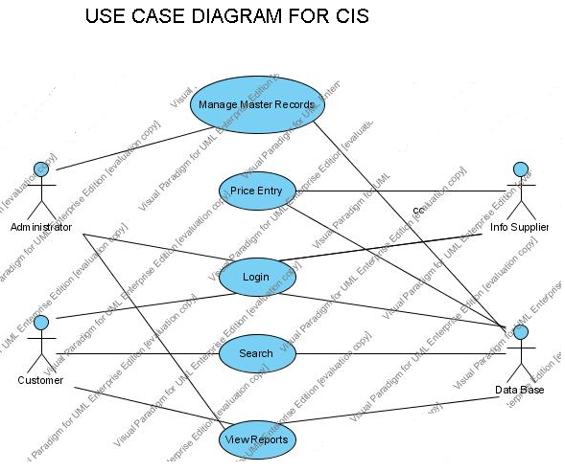

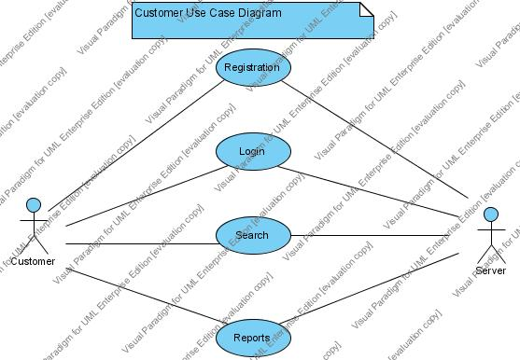

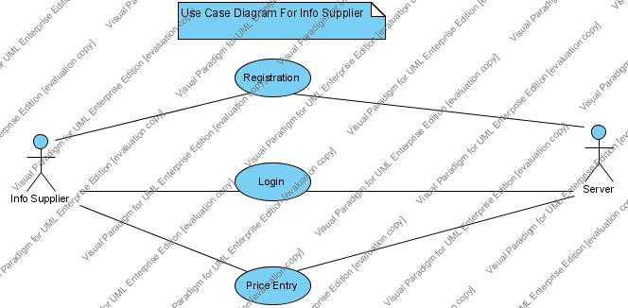

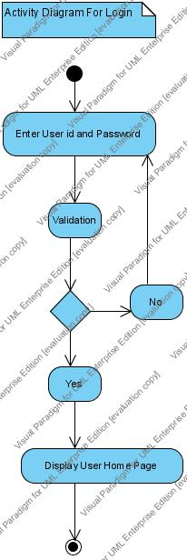

DESIGN:
In this phase, we provide a physical shape to all the models that are created in the analysis phase. The design phase is used to physically create different elements of the project. This phase involves the following sub-phases.
5.1. Module Design:
In this step, we identify the modules and sub-modules of the project. Module is the functional unit of a project. The modularity of a project depends upon the functional requirements and also the users of the project. In this step, we identify the modules and sub-modules of the project. Module is the functional unit of a project. The modularity of a project depends upon the functional requirements and also the users of the project.
In this project, following functional modules are identified.
- Administrator: This module involves all the functionalities meant for the administrator.
- Agent: This module involves all the functionalities meant for the agent.
- CUSTOMER: This module involves all the functionalities meant for the customer

5.2. Data Design:
Data dictionary is a document, which describes the database design of the project. In this step, we generate the data dictionary using the E-R Model of the system. Each entity is represented as a table here. The Data dictionary describes the tables, their fields, data types and constraints on the fields. The Data Design transforms the information domain model created during analysis into the data structure that will be required to implement the software.
Data Design is the first of three design activities that are conducted during software engineering. The impact of data structure on program structures and procedural complexity cases data design to have a profound influence on software quality. The concept of information hiding and data abstraction provides the foundation for an approach to data design. The primary activity during data design is to select logical representation of data objects (data dictionary) identified during the requirements definitions and specifications phase.
It is the process of designing database files, which are the key source of information to the system. The files should properly, designed planed for collection, accumulation, editing the required information. The objectives of the file design are to provide affective auxiliary storage and to contribute to the overall efficiency of the computer program components to the system.
FIRST NORMAL FORM:
A relation R of this system is said to be in first normal form, if all domains contain atomic values.
In this project the Data in each table has atomic values but the data are redundant. so, I consider next normal form i.e., Second normal form.
SECOND NORMAL FORM:
A relation R of this system is in second normal form as if every irreducibly dependent on primary key. Coming to child tables we will be having a reference to the primary key of master table.
In this project I normalized the data tables up to second normal form.

5.3. Interface Design:
In this step, we design all the interfaces for the application. Interface is the medium between the user and the system. We consider all the client specifications while designing the screens and reports.
Every user interface has been designed so that the system provides all the characteristics like easy to use, less number of keystrokes to complete an action, less usage of left hand, easy too learn, easy to navigate, consistent, error-free and functional.
The entire interface that has designed with the features listed below:
- Every action is provided with a prompting message. So that it provides a better communication.
- Every interface maintained consistent navigation, menus, icons, colors, shape and layout.
Every page has been designed so that it optimizes the user’s work efficiency.

5.4. Test Case Design:
In this step, we design all the test cases, which are used by the testers to test the application after construction. Test case is nothing but a sample input or sample activity performed to test for any errors or bugs in the application. In order to perform system testing, we’ve developed many test cases. Some of them are as follows.

S.No | Input | Expected Behavior | Observed Behavior | Status  Pass(P)  Fail(F)
1 | Enter the Wrong login-id and password to login | Error Message indicating the status of the user | -do- | P
2 | Enter correct hint answer in password recovery form to recover password | Display the password of the user | -do- | P
3 | Enter an existing login-id in the user registration form | Error message “login_id already exists. Please choose another one”. | -do- | P
4 | Delete a gallery which contains products | Error message “Gallery cannot deleted because it is not empty.” | -do- | P
5 | Enter bid amount less than base price | Error message “Bid cannot be evaluated as the bid price is less than base price.” | -do- | P
6 | Send message without body | It should display an error message “Message body cannot be blank” | -do- | P

6. CONSTRUCTION:
This is the actual constructive phase of the project where the models and designs are added with functionality. The construction phase involves coding, compiling and building the functional modules of the project.

CIS Project screen shots

Home Page

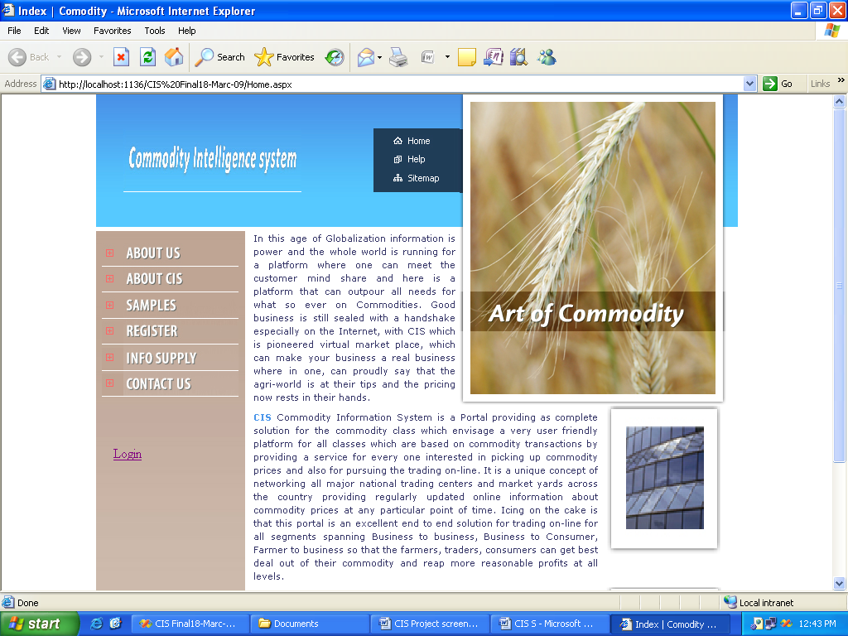

Customer Registration

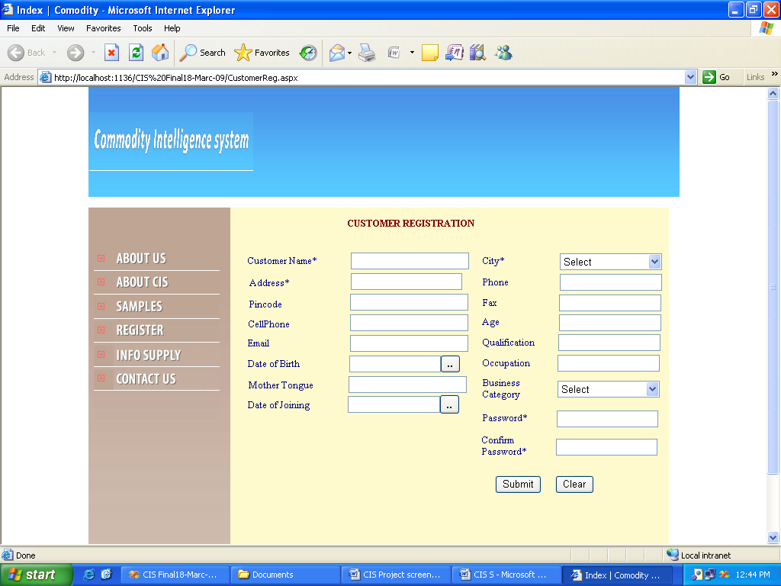

INFO SUPPLIER REGISTRATION SCREEN

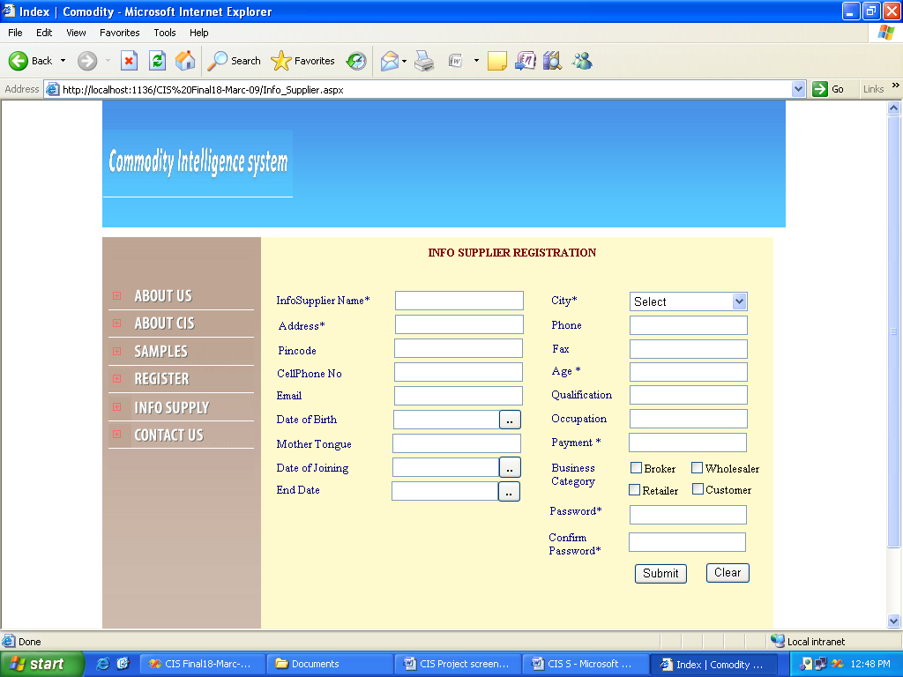

LOGIN SCREEN

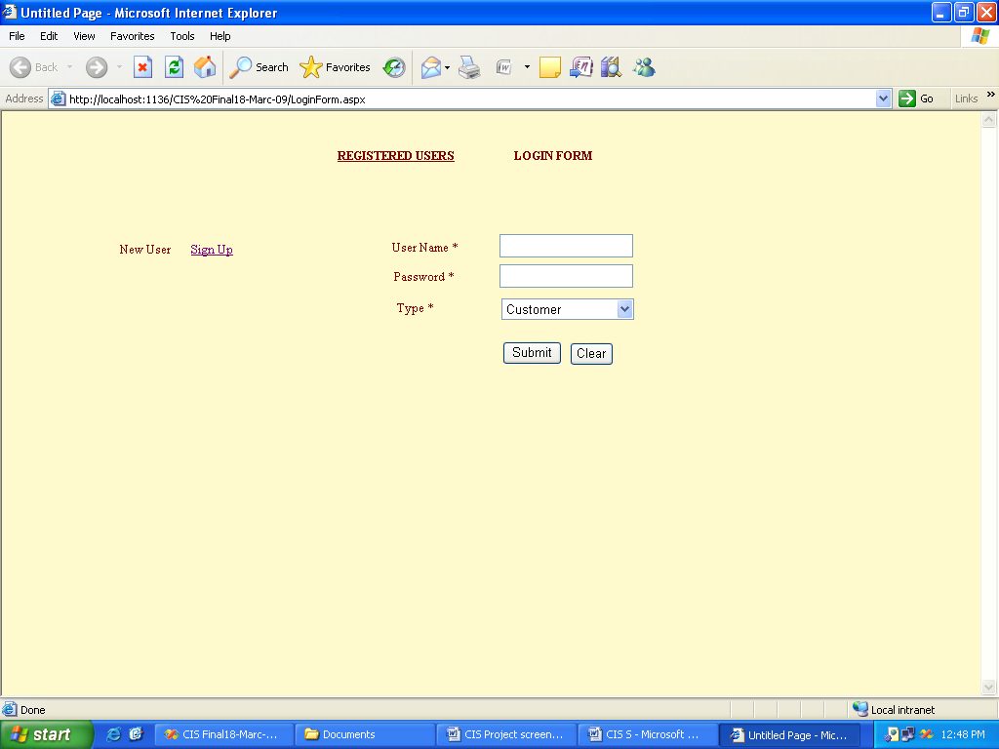

ADMIN HOME PAGE

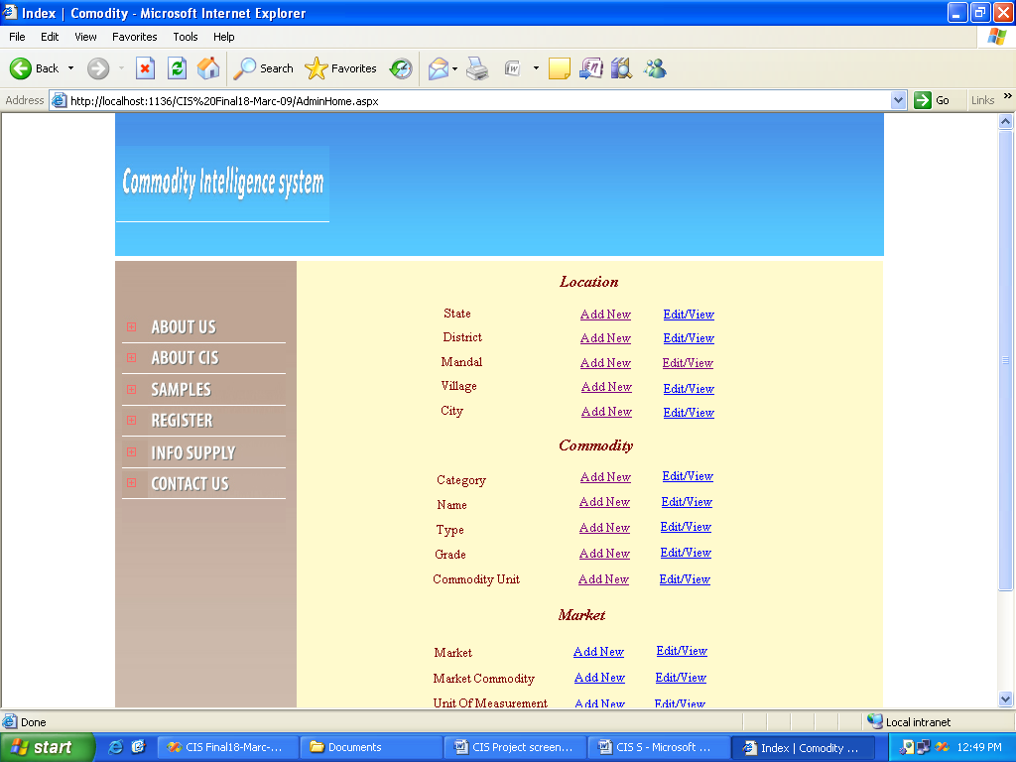

ADMIN HOME PAGE

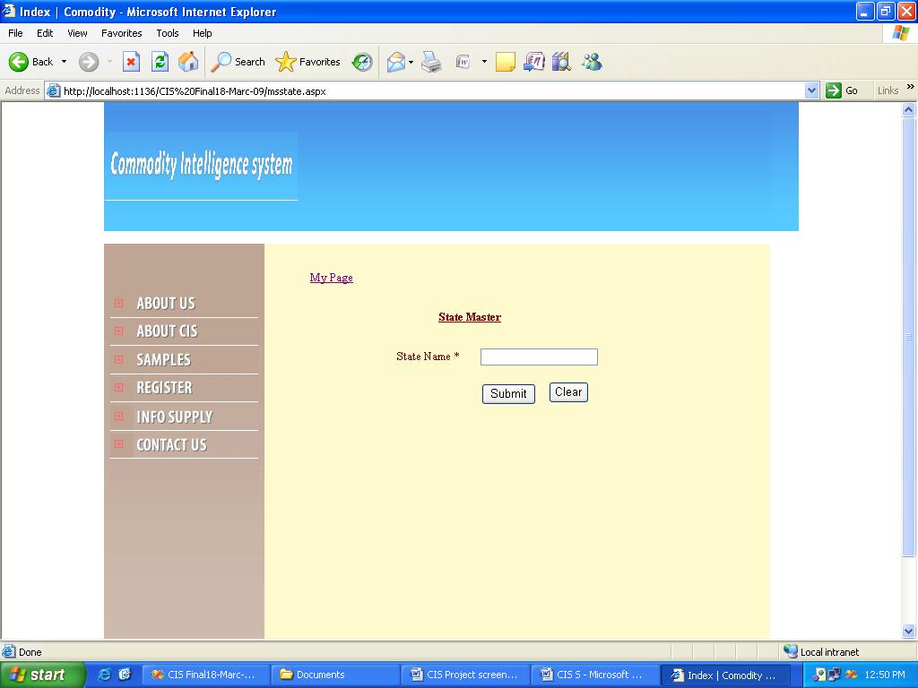

LOCATION ---- MADAL ENTRY SCREEN

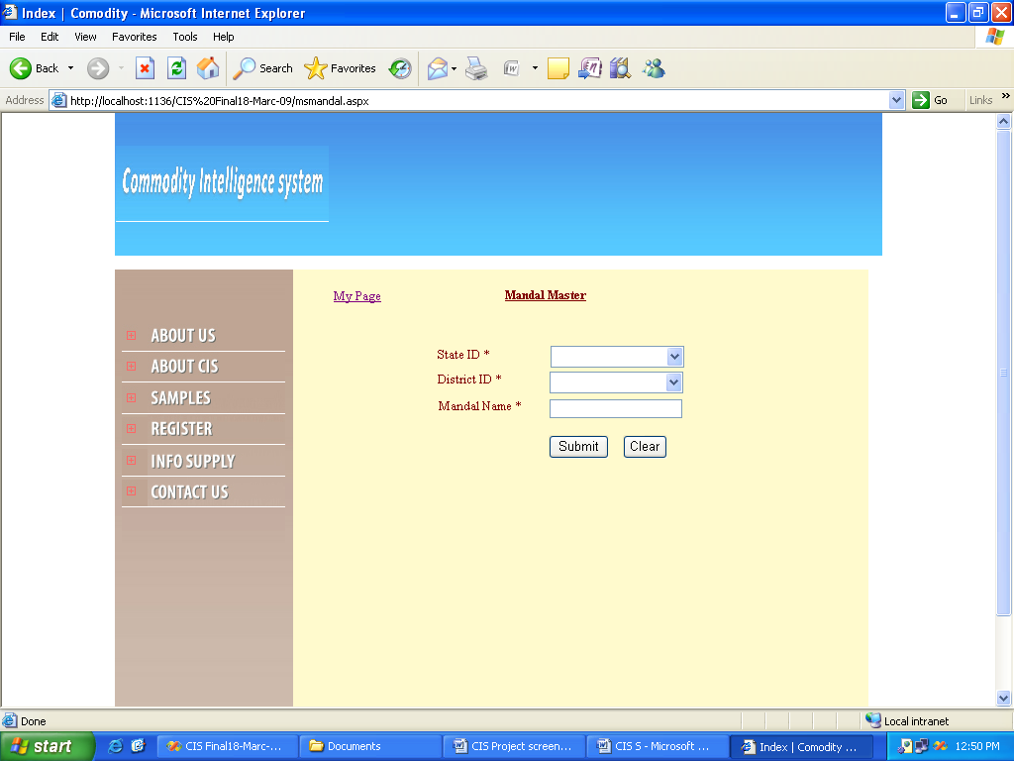

LOCATION – VILLAGE ENTRY SCREEN

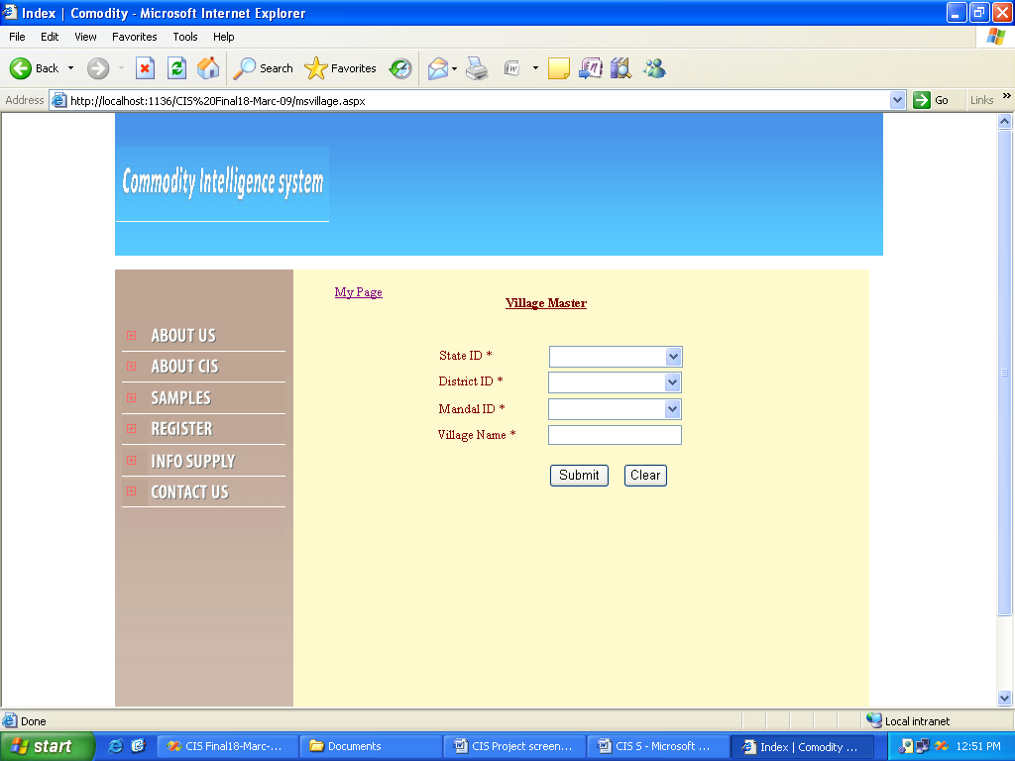

COMMODITY – CATEGORY ENTRY SCREEN

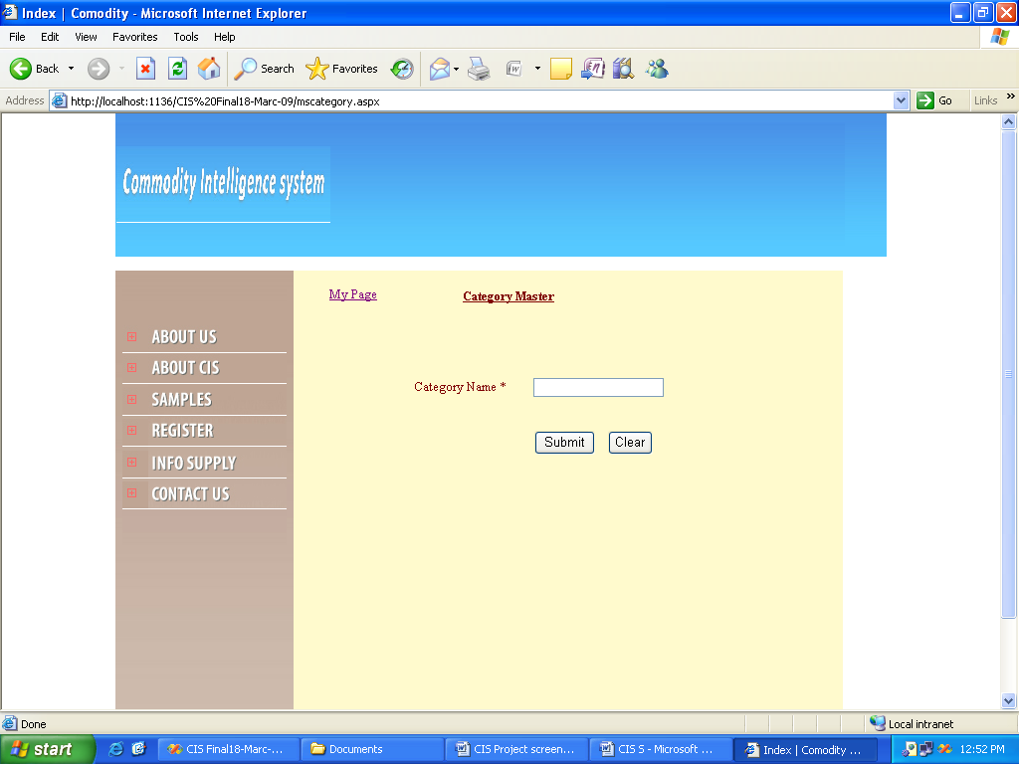

COMMODITY – TYPE ENTRY SCREEN

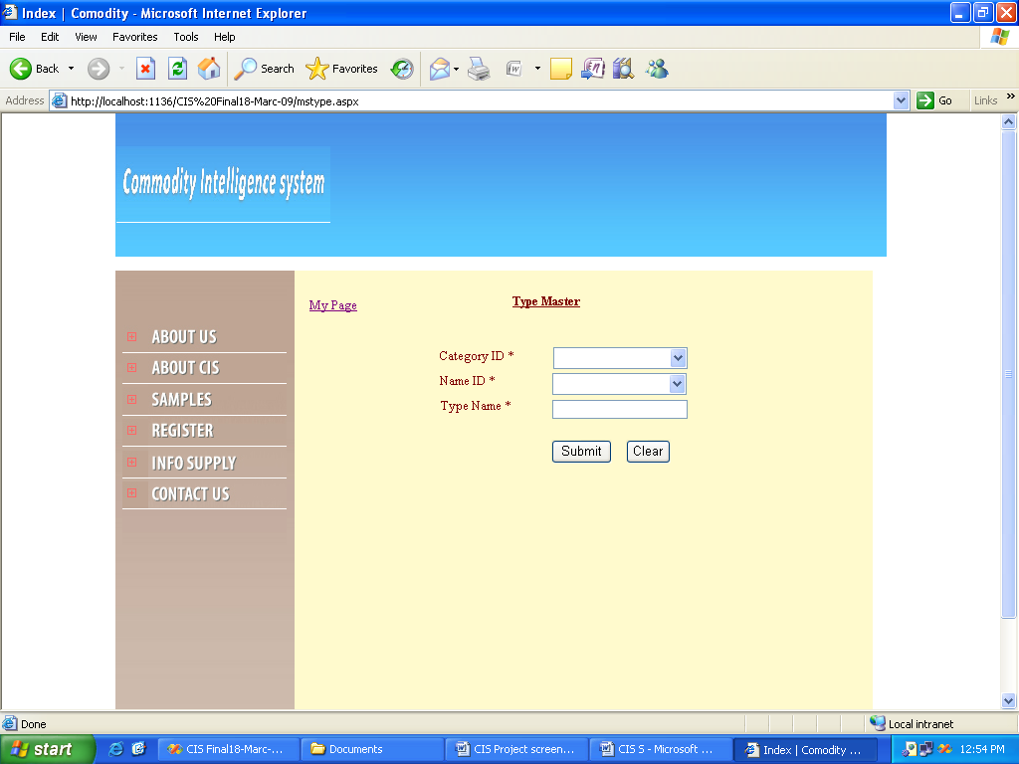

COMMODITY – GRADE ENTRY SCREEN

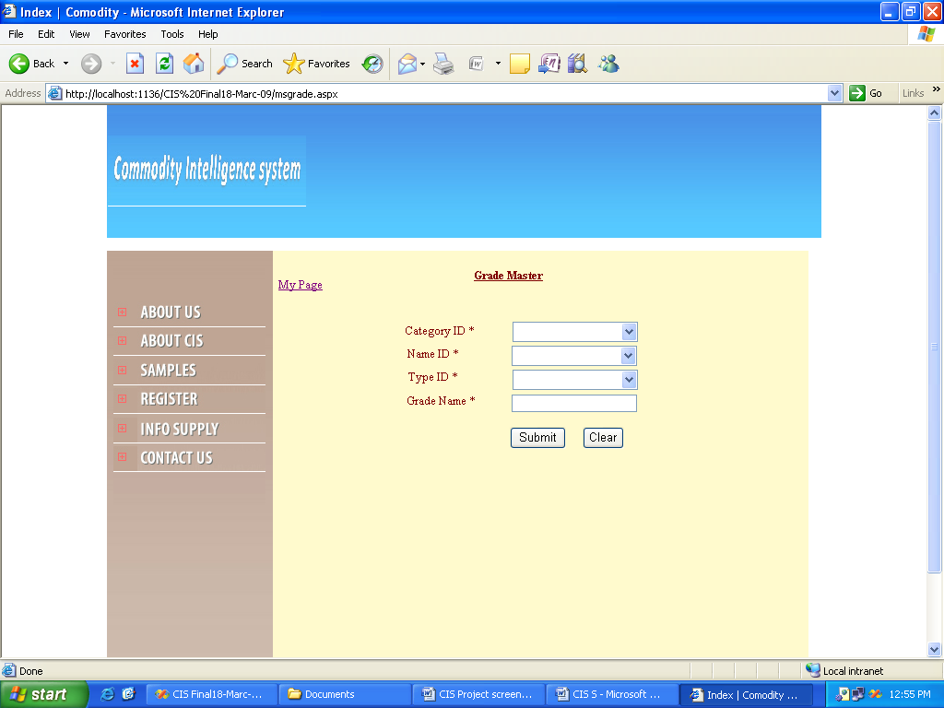

COMMODITY – UNIT ENTRY SCREEN

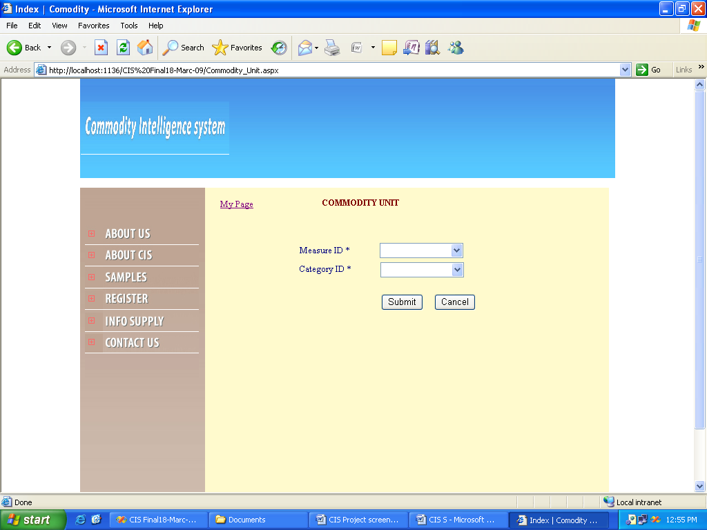

MARKET ENTRY SCREEN

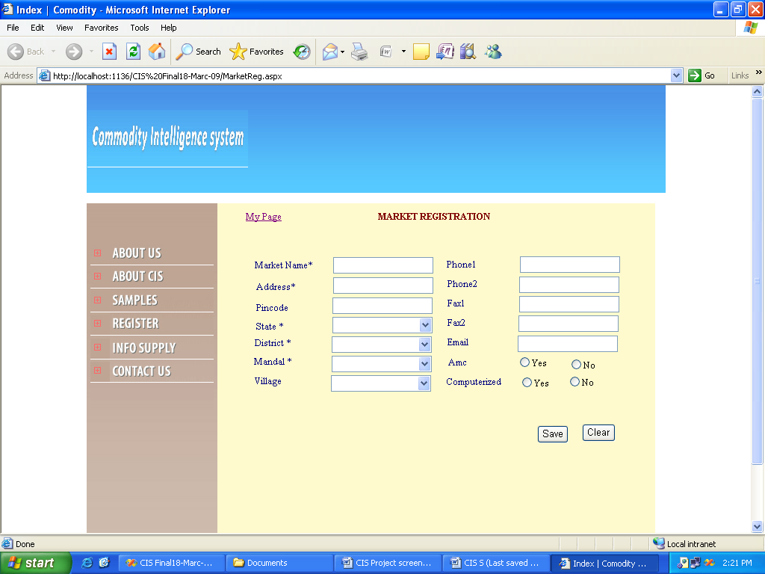

MARKET COMMODITY

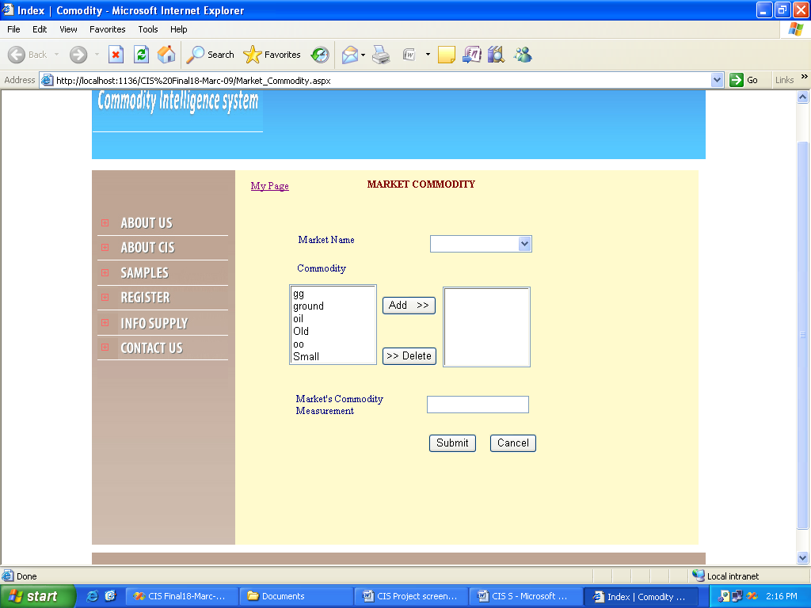

UNIT OF MEASUREMENT ENTRY SCREEN

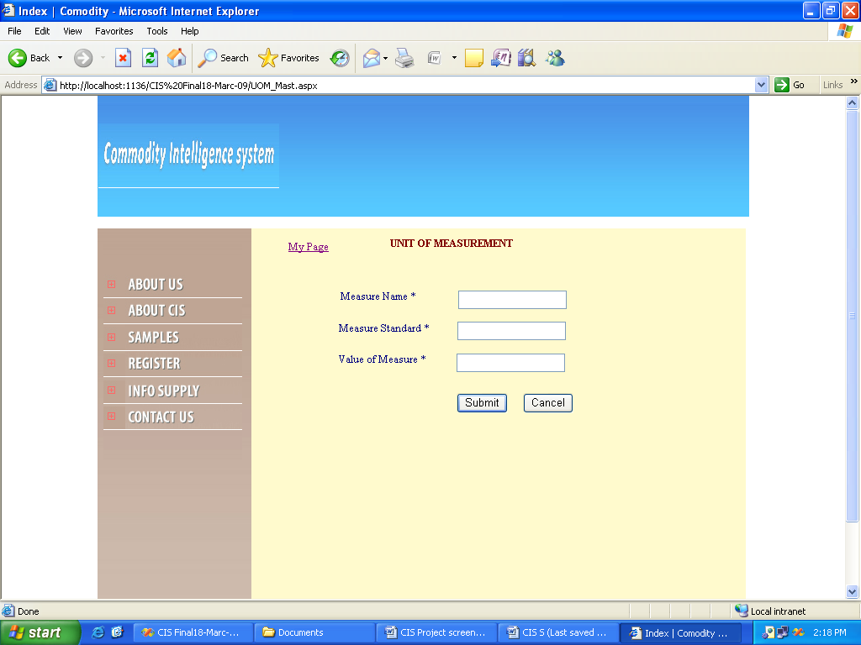

CIS REPORTS

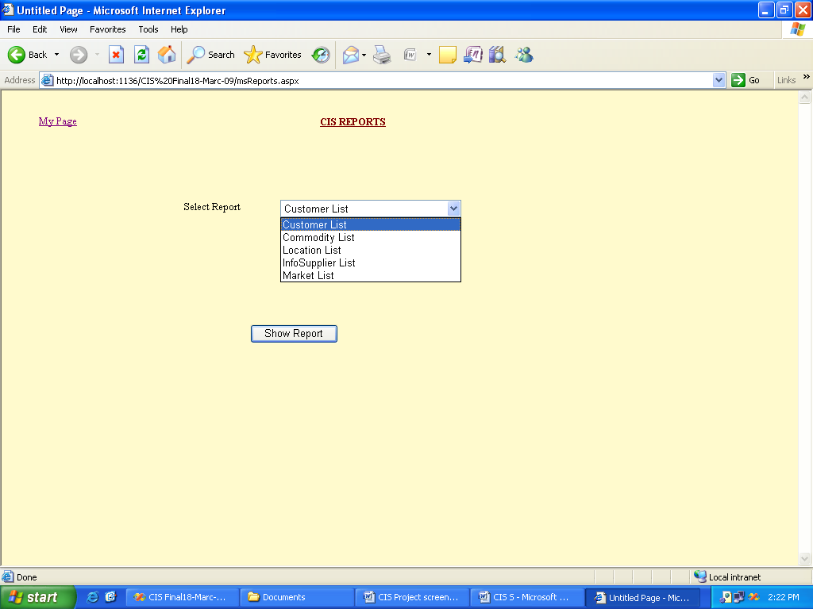

7. TESTING:
TESTING
Testing is the process of exercising software with the intent of finding errors. The Web-app testing is a collection of related activities with a single goal: to uncover errors in web application content, function, usability, navigability, performance, capacity and security.
There are several areas of testing involved in web applications. For the current web application, I used some of them as follows.
CONTENT TESTING
Content testing attempts to uncover errors in content of the web application. In addition to examining static content for errors, this testing step also considers dynamic content derived from data maintained as a part of database system that has been integrated with the web application.
Content testing of all web pages is evaluated for syntactic and semantic errors.
At syntactic level I have verified the content for spelling, punctuation and any grammar mistakes of all pages which contain the content of the website.
At semantic level I have verified for the following aspects.
- Whether the content is valid or not.
- Whether the format of the content is good and readable or not.
- Whether all the web pages are showing consistent content or not.
The content includes the dynamic information about the companies, stock values and flowchart details which is fetched from the database. The consistency of this information is thoroughly tested.
DATABASE TESTING
Database testing is done to uncover the errors which occur as a consequence of fetching large equities of data from the database, extracting relevant data from the database, accessing the database using several queries etc,
In this project, I have tested the application for database errors in following areas.
- While converting the user request into a database query
- While fetching dynamic content to the web pages.
- While opening and closing the active connections to the database
- While presenting the raw data fetched from database in a formatted HTML output.
- Communication between the web application and the remote database.
USER INTERFACE TESTING
All the interfaces that have been designed are reviewed whether they meet the customer requirement or not. While testing all interfaces I have verified for errors as follows.
- Errors related to specific interface mechanisms for example proper execution of all menu links that are provided in each web page
- Errors related to all semantics of navigation and web application functionally that is provided in each web page.
- Errors in consistency related to different aspects of the interfaces like font style, color, size, screen background color etc.,
- Errors in viewing the interfaces in different web browsers like Microsoft internet explorer, Mozilla firefox etc.,

INTERFACE MECHANISM TESTING
When a user interacts with a web application, the interaction occurs through one or more mechanisms which are called interface mechanisms. Testing done within theses mechanisms is the interface mechanism testing. This testing is done in following areas.
Links:
Each navigation link is tested to ensure that appropriate web page is linked or not. I have listed all the links in each form to test whether each link is connecting the appropriate page or not.
Forms:
Testing forms has been done at two different levels i.e. at minimum level and at more targeted level. At minimum level I have tested for:
- Whether labels been correctly defined for fields or not.
- Whether server is receiving all the information contained in the form and no data are lost in the transmission between client and server.
- Whether appropriate default values are available when the user does not select any item in the selection box.
- Whether scripts that perform data validation from the client-side are working properly or not.
At more targeted level I have tested for:
- Whether text fields have proper width to enter data.
- Whether text fields are allowing string length more than specified length.
- Whether tab order among different controls is in required order or not.
Client Side Scripting:
Each and every function written in scripting has been tested by Black Box Testing.
I have combined the forms testing with this client-side script testing, because input for scripting is provided from forms. Some methods of scripting will be performed in some particular browsers and in others not. So I have also performed compatibility testing to ensure that the scripting functions will work properly in all browsers.
USABILITY TESTS
In this testing I have verified up to, which level that, users can interact with the system effectively. Tests are designed to determine the degree to which the web application interface makes users easy to work with. I have designed test case so that usability testing can be verified at different levels:
- Usability test has been performed on each and every individual interface i.e. forms.
- Usability test has been performed on total web page with related client side scripting functions.
- Usability test has been performed on total web application.
COMPATIBILITY TESTS
As this is a web application, it should run on different environments like different computer architectures, operating systems, browsers and network connection speeds.
As different computing configurations can result in difference in client side scripting speeds and display resolution, operating system variance may cause web application processing issues.

Different browsers produce slightly different result as we expected, in some cases this results may not be a problem but in some cases there will be serious errors.
To perform these testing strategies first we have prepared what are all the client side functions that encounter problems with different compatibilities. In essence of those we have tested by identifying different computing platform, typical display devices, the operating systems supported on the platform, the browsers that are available with me.
NAVIGATION TESTING
Navigability is tested to ensure that all navigation syntax and semantics are exercised to uncover any navigation errors. (ex: dead links, improper links, erroneous links). The job of navigation testing is to ensure that the navigation mechanisms are functional, and to validate that each Navigation Semantic Unit can be achieved by the appropriate user category.
We have done the navigation testing in following areas.
- Navigation links are thoroughly tested.
- Redirects are properly checked.
- Is the target page to a navigation link is correct or not.
- Is the link caption meaningful or not.
8. DEPLOYMENT:
The error-free project, which passed all the tests, is now deployed at the client environment in this phase.

BIBLIOGRAPHY
Books
SOFTWARE ENGINEERING
Roger.S. Pressman
Database System Concepts 4th edition
Silberschatz, Korth, Sudarshan
Designing the User Interface, 3rd edition
Ben Shneiderman
Websites
www.w3schools.com
www.programmersheaven.com
www.google.com

